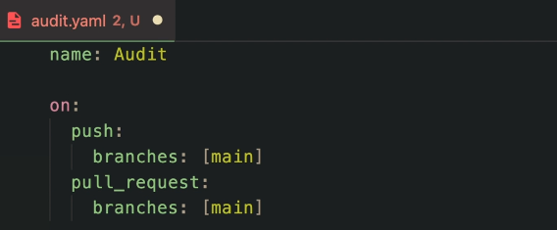

So the first thing we're going to do is that I'm going to call this audits. Now this is the name you can call whatever you want workflow CI, whatever you want.

And I'm going to run this workflow on push. And then I'm going to specify the branches that I want for this to to run. And this is going to be on main or whenever you create a pull request as well. So if you're working on a team with people, it's nice that you also include the pull requests as well. So that's this whole flow runs that as well.

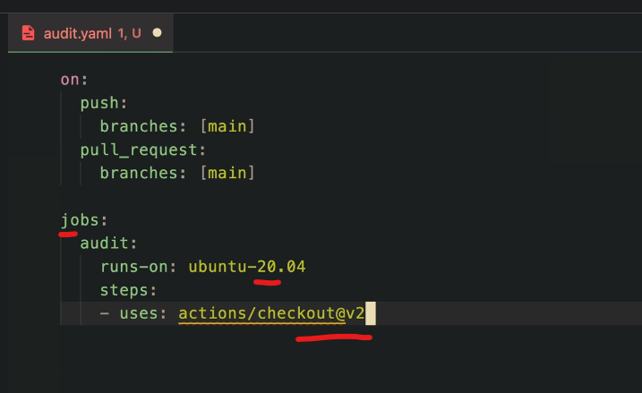

So that's this whole flow runs that as well. Then the jobs I'm going to do one which is called audits. It's the only job we're going to do. And this is going to runs on ubuntu. And here I'm going to specify a version for example this one, the one I usually use. Basically this is going to set up an ubuntu machine or image for us to to run these steps, because we need to use some functionalities that then specify the first users. And this is going to be the actions slash checkouts at v2.

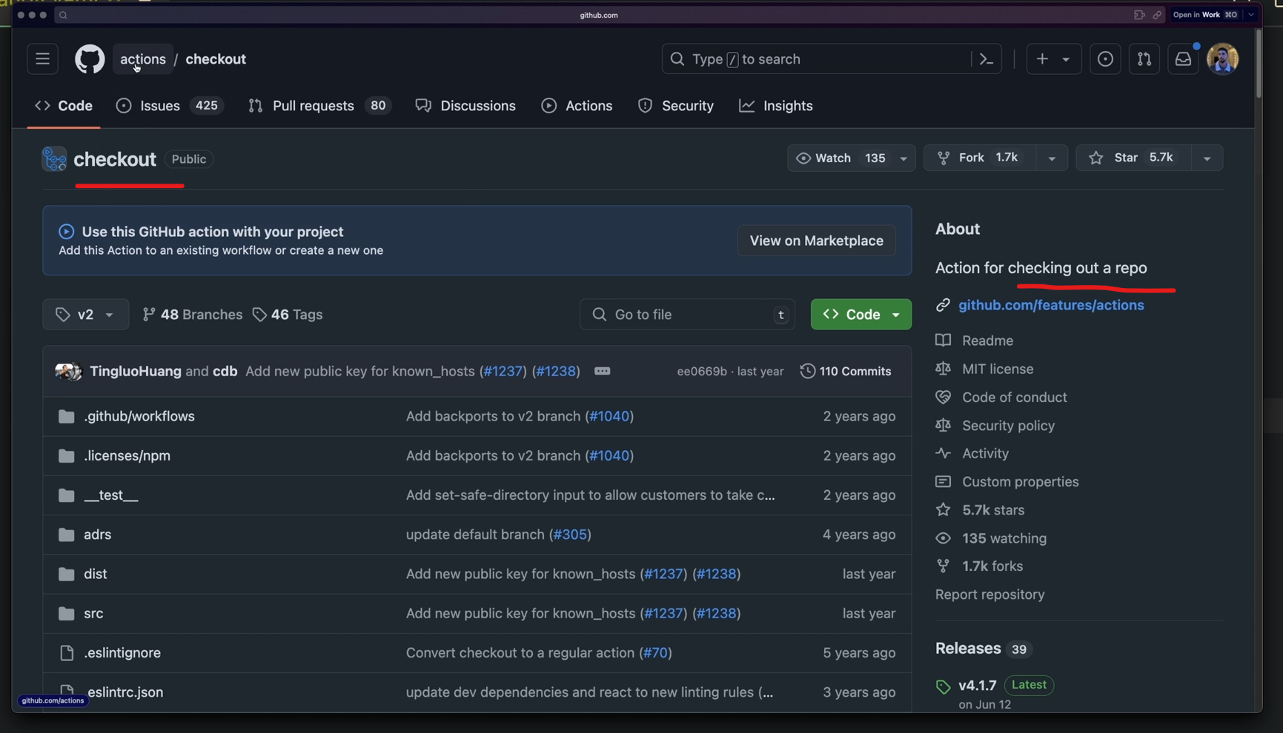

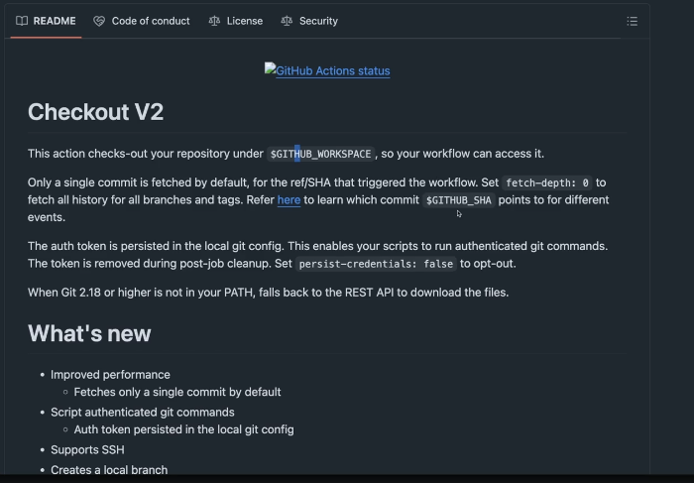

Now if you click this link and you see what this is, this is basically an actions or an official image from the actions team here. And it's called checkout. And this is basically it's just an action for checking out the repo. And you think this is just simple. It's not because **it requires a lot of stuff to happen. GitHub authentication tokens and all of that. So this image handles all of this for you. You just need to consume it.**

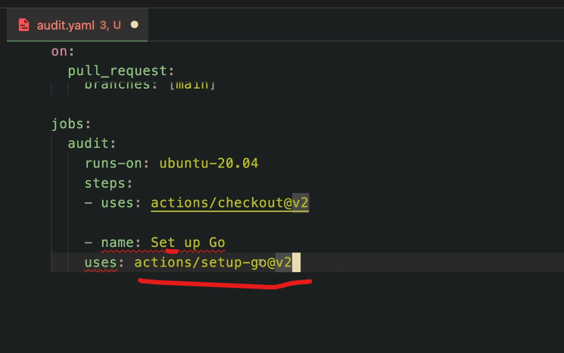

**And then the second step we're going to do I'm going to set it a name here. Let's call this setup go for example. And this is going to use another step which is going to be the setup go v2.**

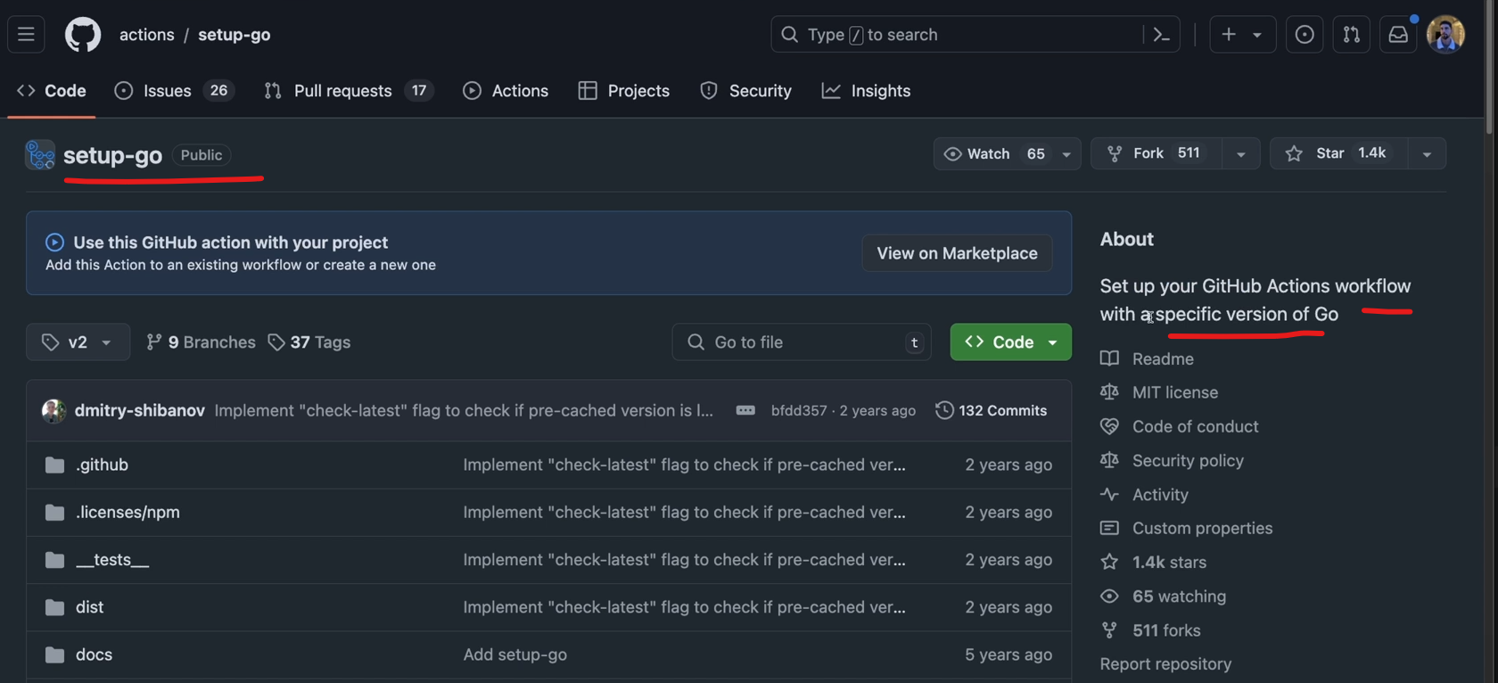

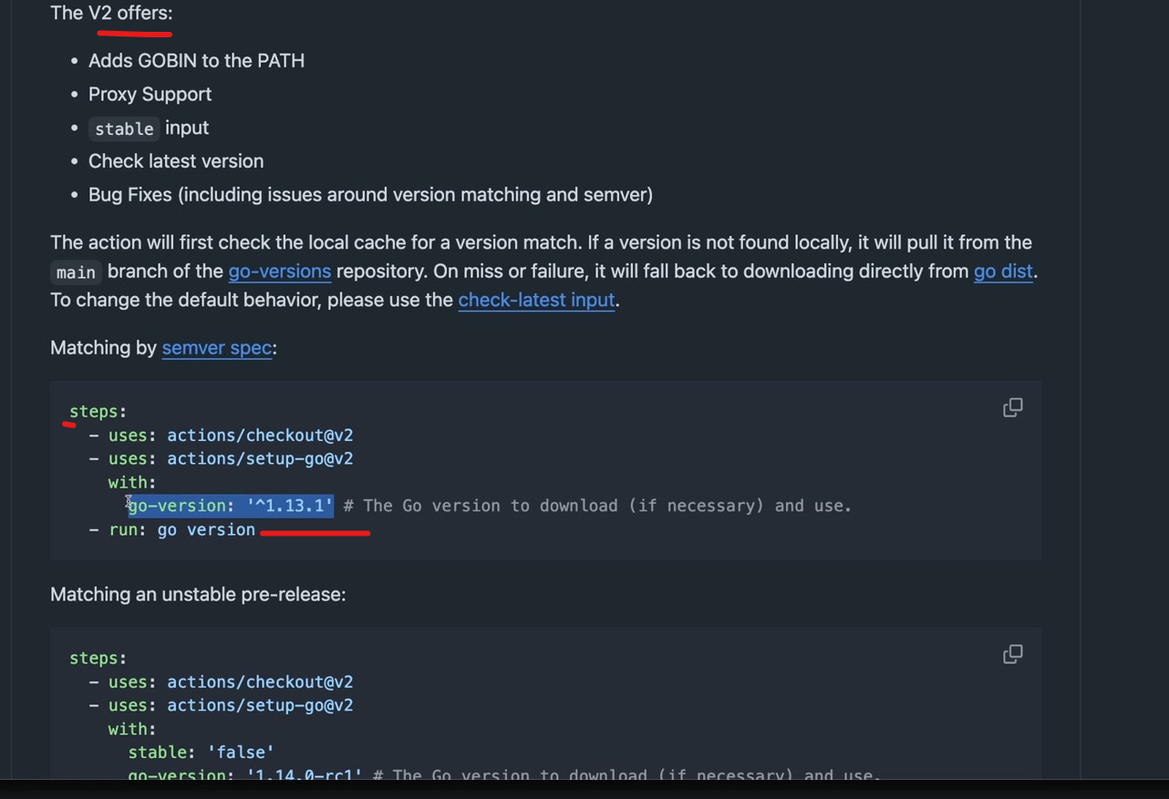

**So let's take a look at what this does. And actually I need to add here a tab to for the syntax. This is YAML after all. So this sets up your GitHub actions flow with specific version of go. So you can even specify your go version which we want to do this. So let's um copy this whole thing here. Let's drop it here.**

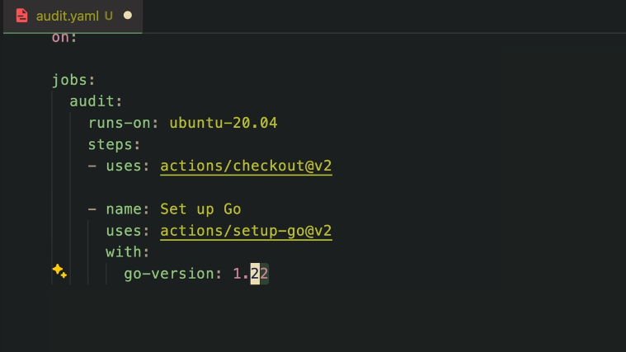

**However our version is one we can actually then in this comments, actually you can just specify 122. That's what we used on our Go.mod file.**

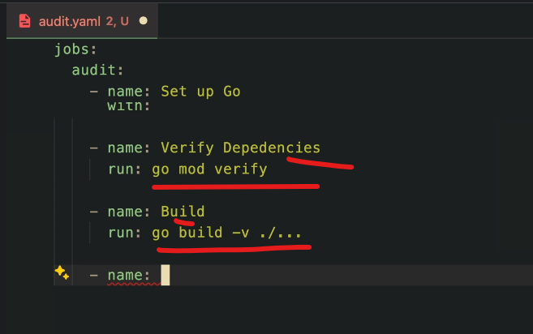

Then let's go to another step. Now that we have a lot of stuff set up, we can start verifying, for example, our dependencies and what's going to happen. We now have go in our CLI. We can just do go mod verify for example. This is going to run these commands and I need to correctly indent this. Uh so this is one step.

Then let's do another one for example to to build our projects. So let's start by building. If it doesn't build there's no need to doing anything else. So go builds slash V and all the files here.

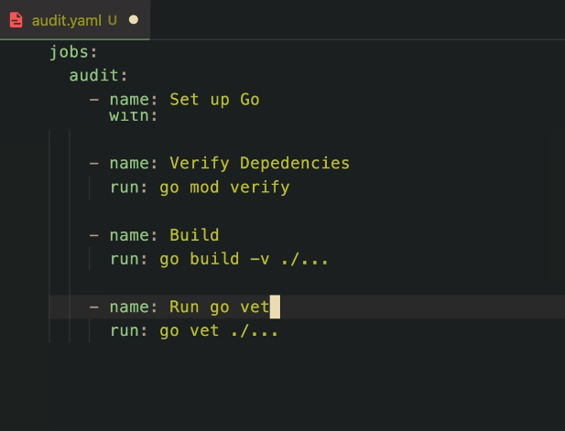

**And the command for these is go vets.**

**Like so. And if you're not familiar with what go that does it basically going to analyze your code to see if you have anything bad happening there. Uh, it's basically another static check.**

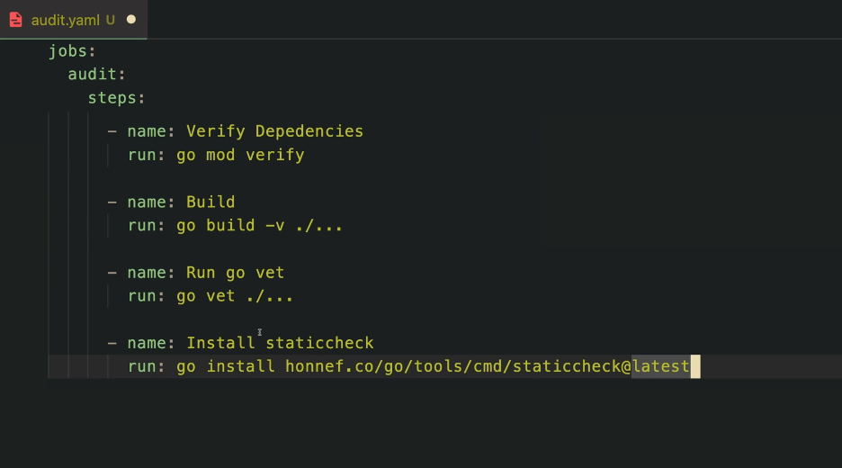

Uh, it's basically another static check. And speaking of static check, let's actually run one from another package, which is called static check. And this is going to run from an action which I think we need to install it first.

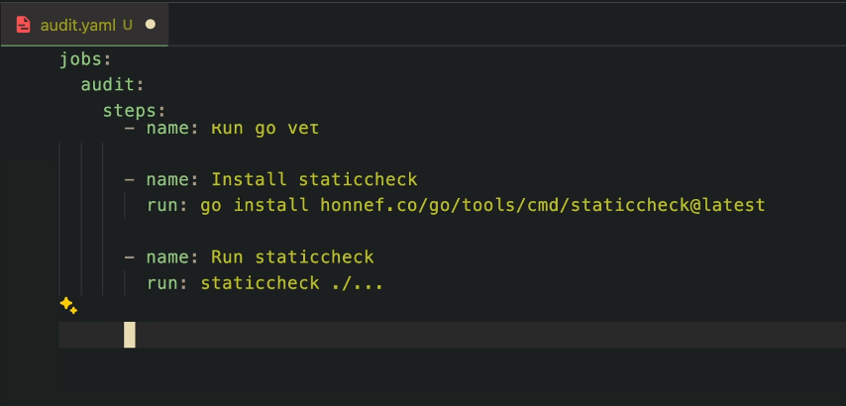

I like to be a little bit more strict and run another static check. This is a little bit more robust. So that is what we're going to do. Now let's run this on every file. I think we can do this. I'm not sure if we specify JavaScript files. This is going to fail. We're going to see. But I think this works though.

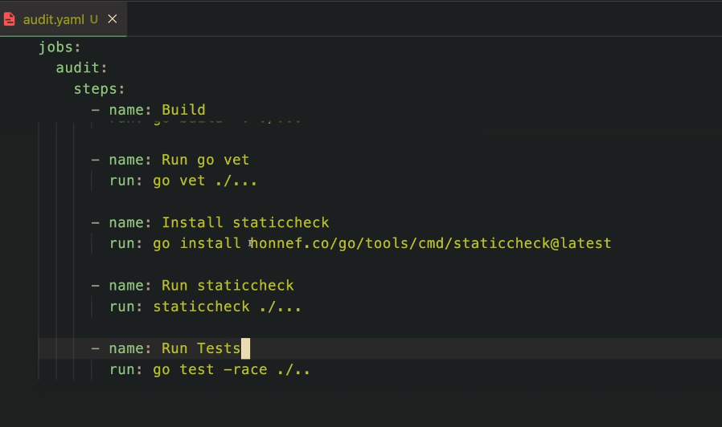

Uh, then we need needs one last step, I promise this is the last one for now. And then this is going to be just a go. Tests. Let's do with a race flag and let's get all the tests. I'm going to call this run tests.

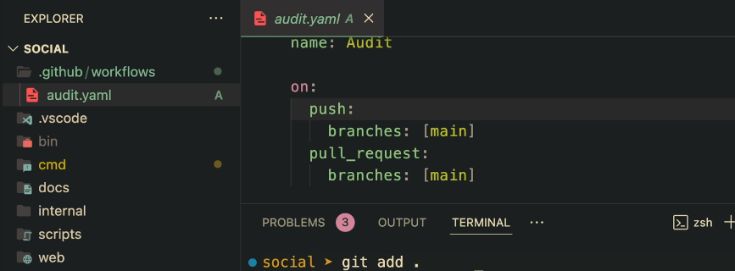

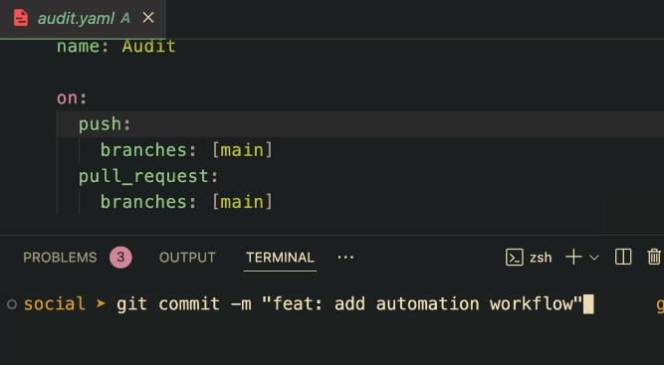

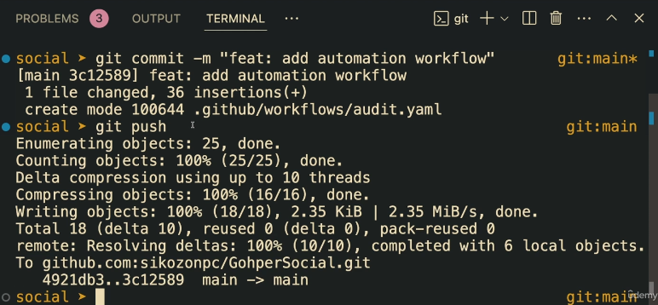

To run this we need to make as you saw here I need to make a branch and push it all. We need to make a pull request. So let's make some changes. I think this is actually considered a change. So we can do a git add everything a git commit. And again I've been using the semver , naming convention already. You see me using Fitz and then a description fix because if you do a git log you can see all of the , the commits I've been using. So let's just go ahead and use, for example, a fit add automation workflow.

Let's commit and let me push this. Now let's go back to the GitHub and see what's happening there.

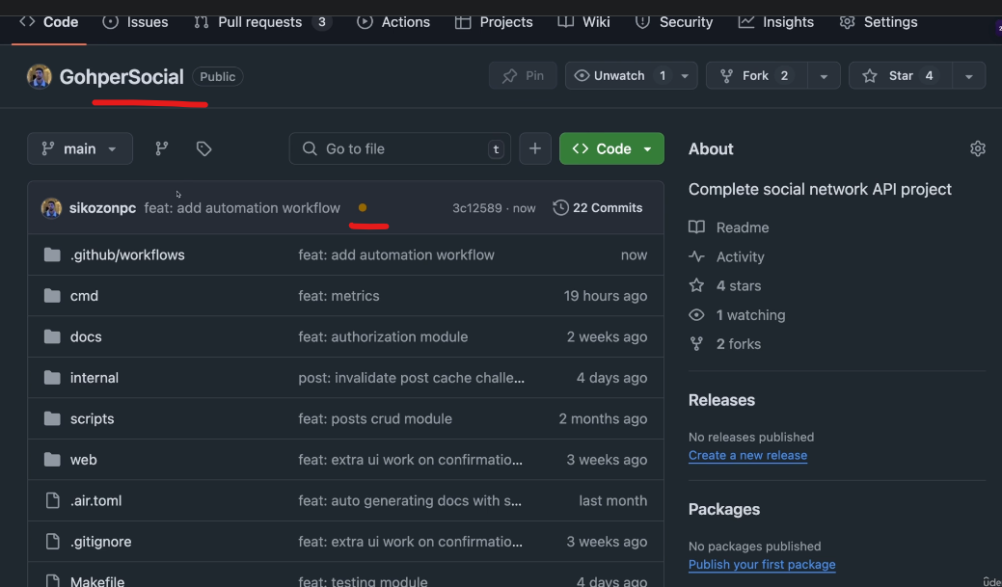

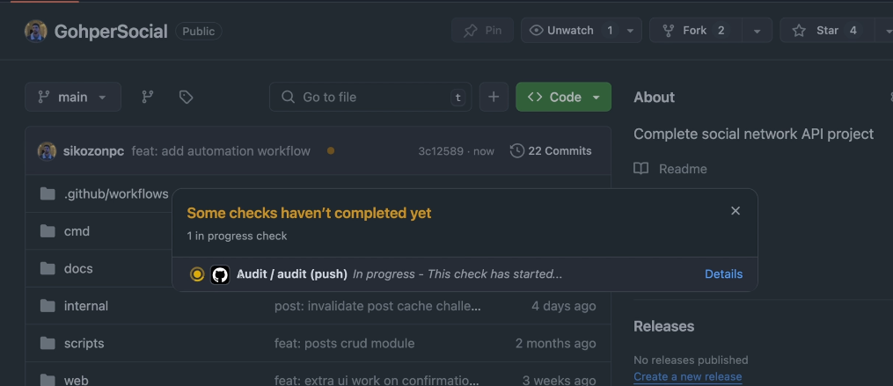

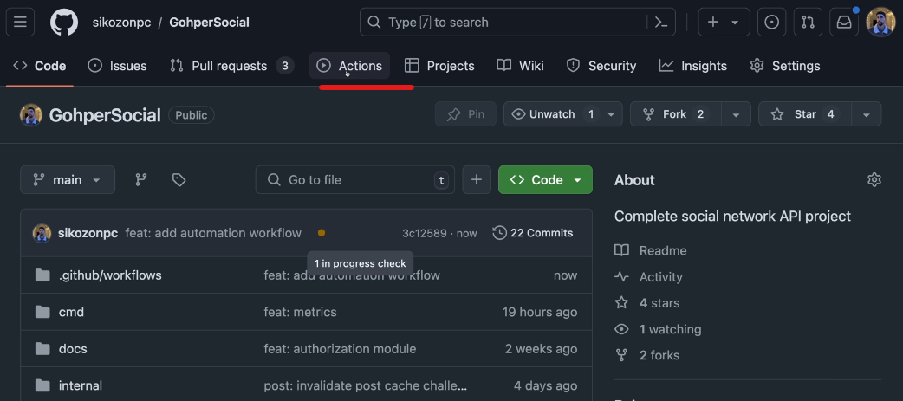

So here I'm on the project and you can see that we have now a pending status here. And if you click it you can see that we have an action running which is this audit. So let's go here to actions.

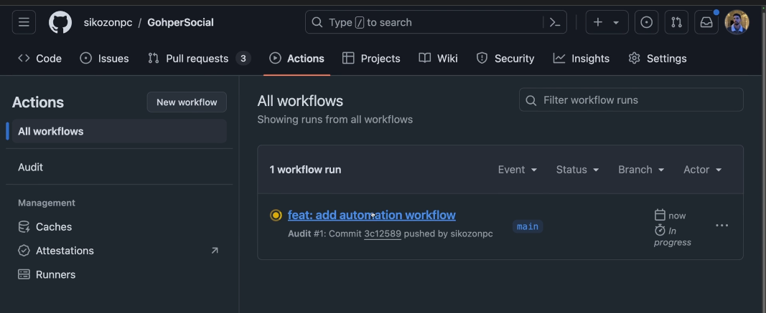

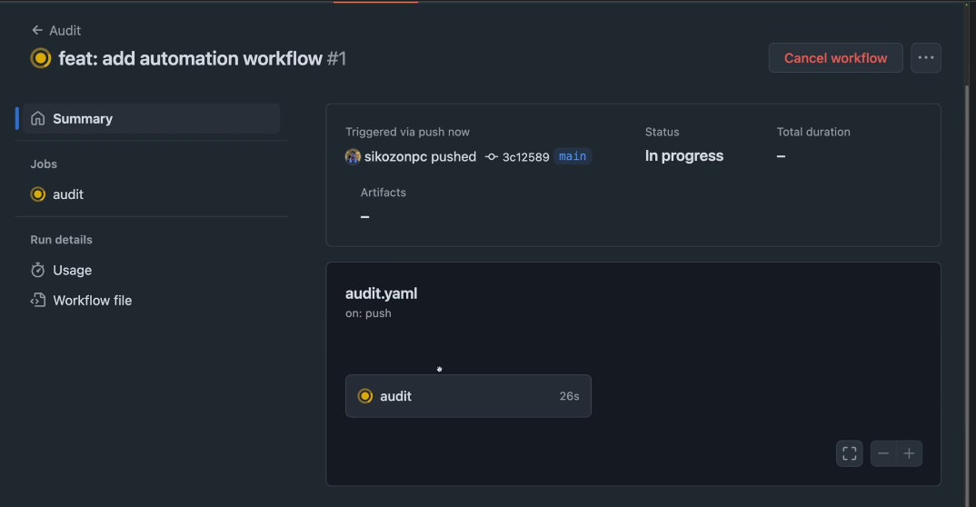

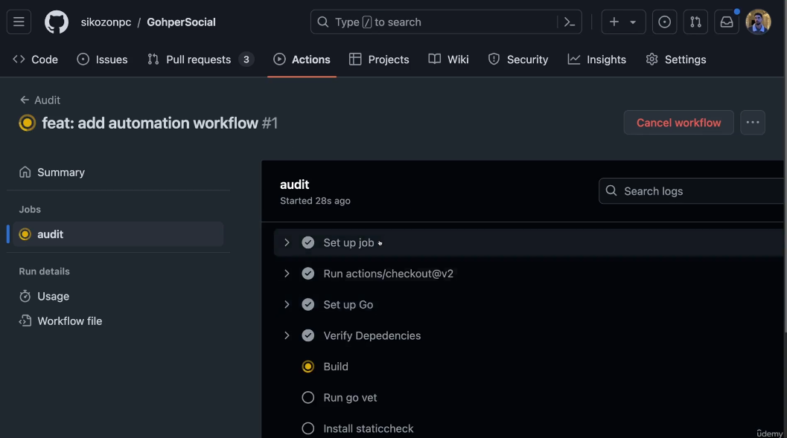

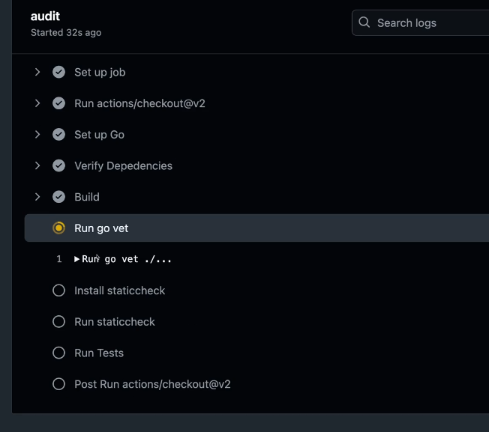

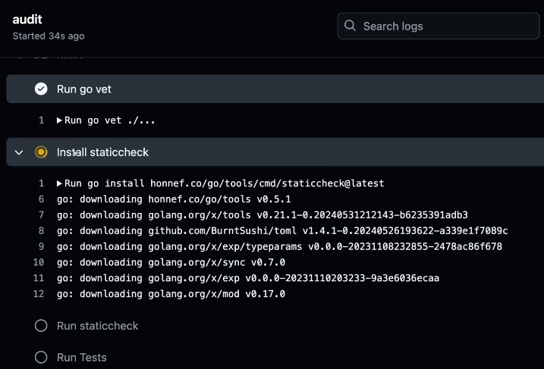

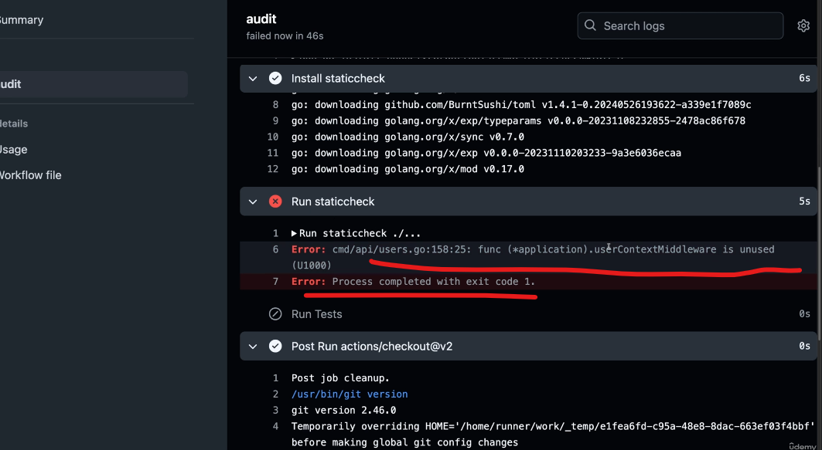

So here I'm on the project and you can see that we have now a pending status here. And if you click it you can see that we have an action running which is this audit. So let's go here to actions. And now here is the page for all of your GitHub actions. If you click it you can see more details on what step it is currently it's building. Then it's going to run the go vet, install the static check.

Let's see if it works here. So everything before this has worked. Something fails. This is going to stop there. And as you can see it has failed on the static check because we have one middleware which is unused. So you can see already the benefits from this.

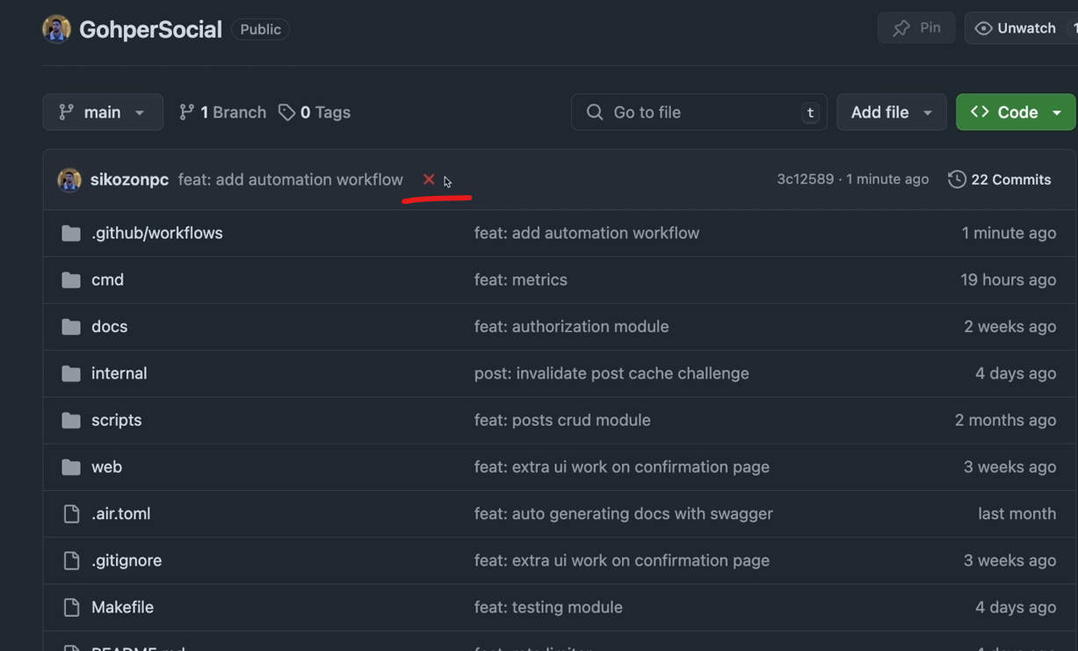

So what we're going to do if you actually let me scroll back out, let's go to our code and you can see that we have a failure. So our build is now failing. Let's go ahead and fix this.

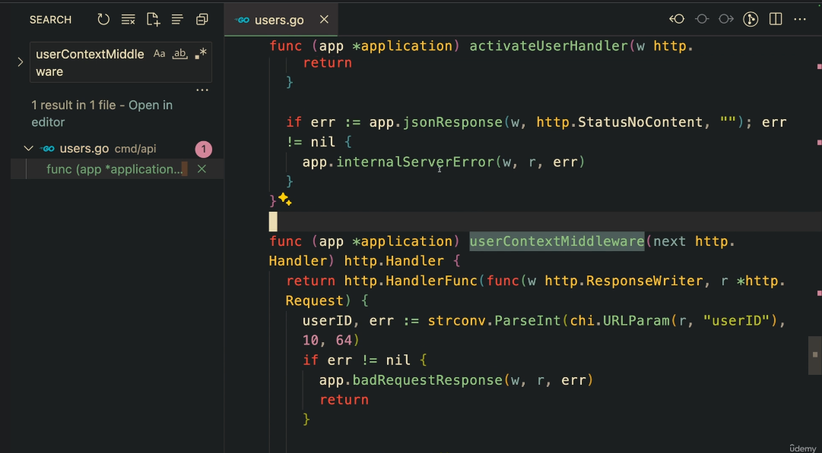

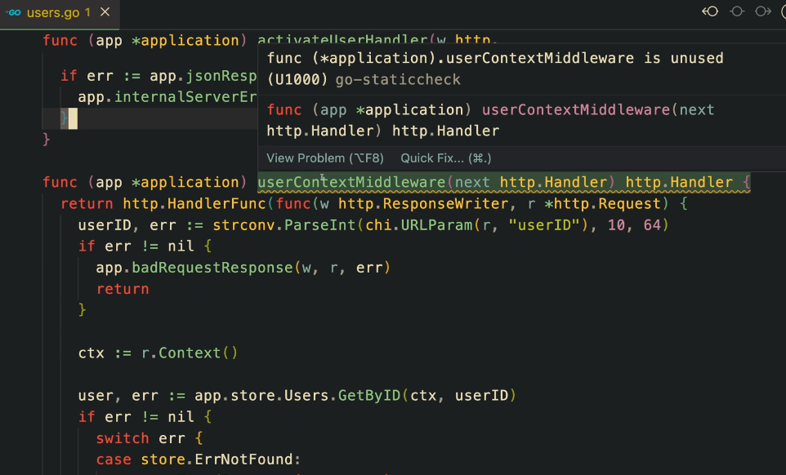

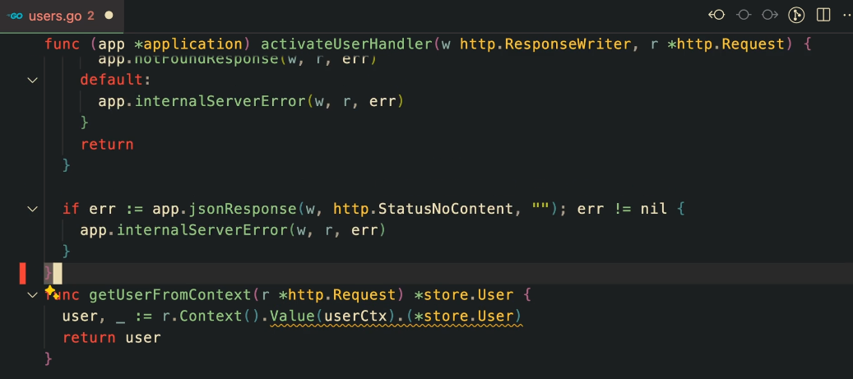

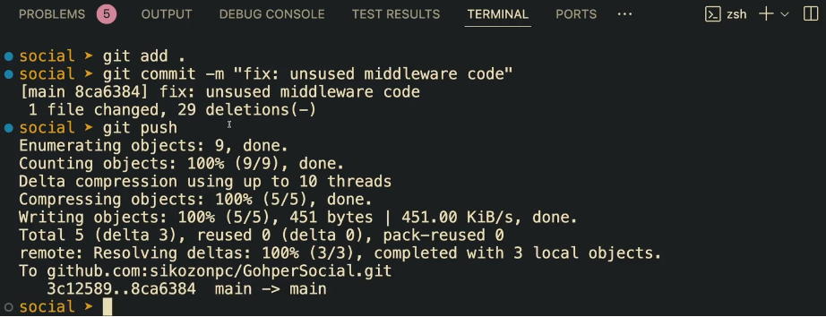

Let's go ahead and fix this. What we need to do is actually what they said, which is if you come here to the Middlewares or to the users, we have this middleware which is unused. So this is basically that code. We can just come here, remove it. There we go. Let's do another push there. So let's do a git adds a git commit. Let's do fix and used middleware codes. Now let's do a git push. And we should have another build coming up.

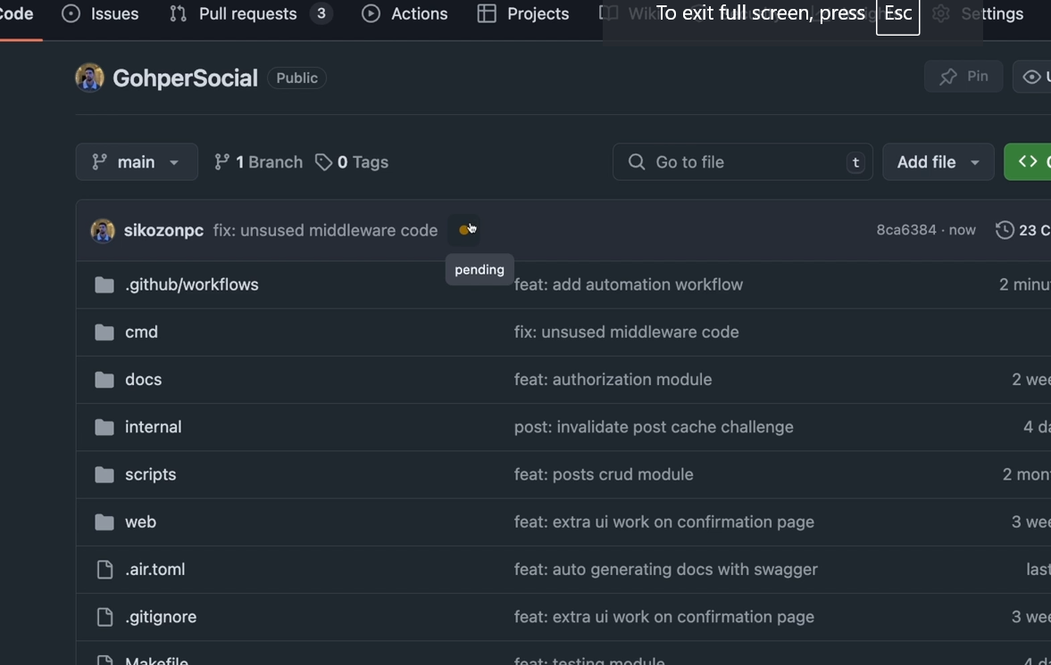

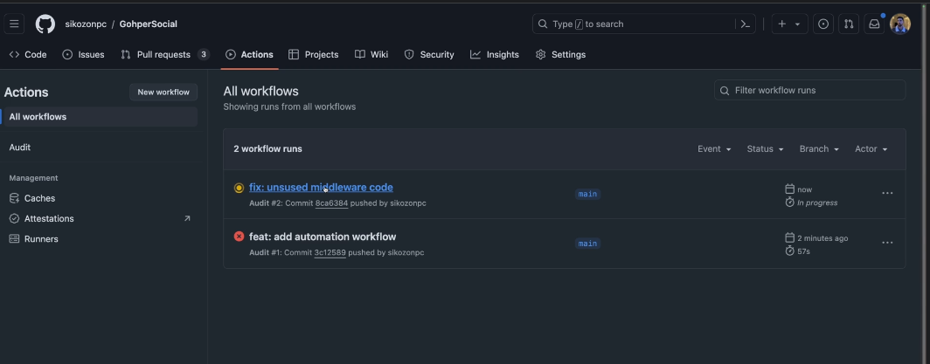

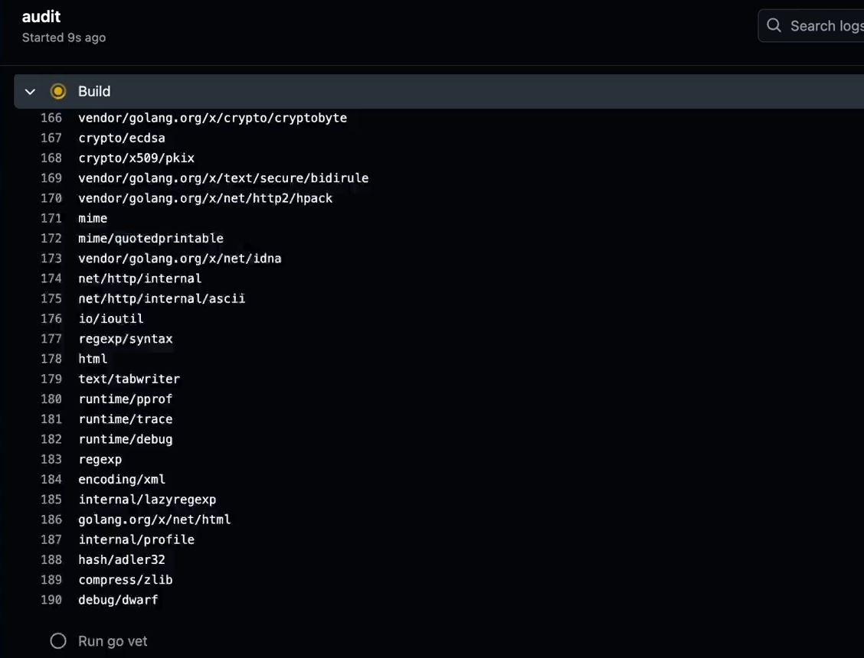

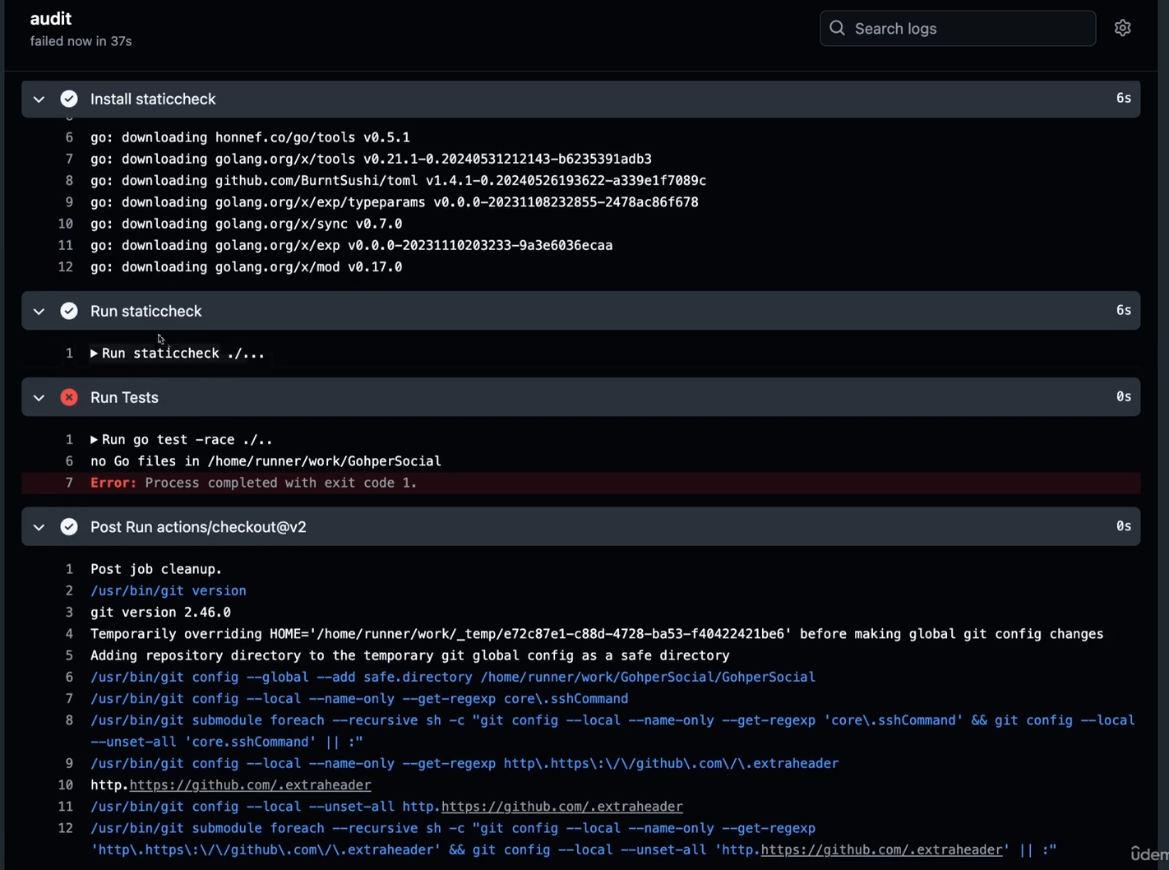

So let's just do a refresh. As you can see we have a new pending build. Let's go to the actions and let's see what's going on here. As you can see, even the go vets before didn't cut this and used function. That's why I like to install static check because it's got stuff like this. So let's see if it fails. Now.

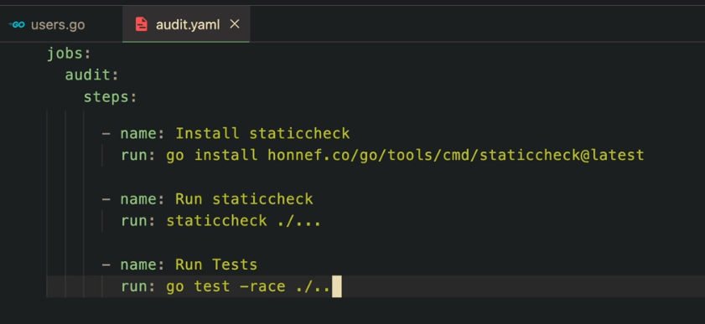

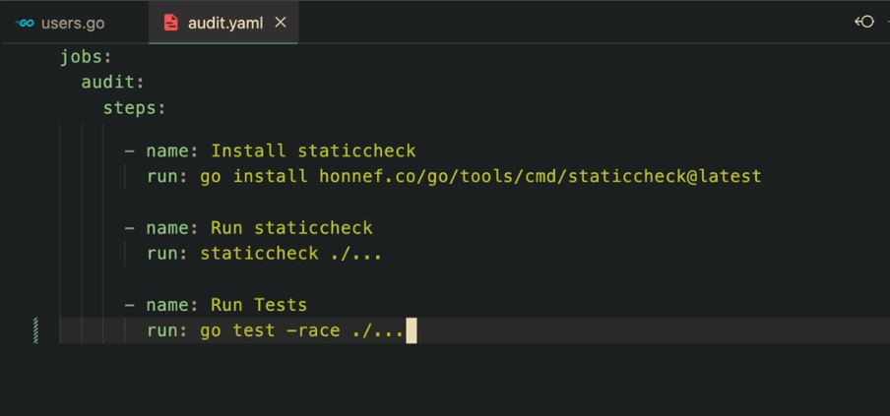

So our static check has passed, but our goal test has failed and that is because I mistyped something there. There is no files on this folder and it makes sense because I did a mistype. I forgot to add one dot here.

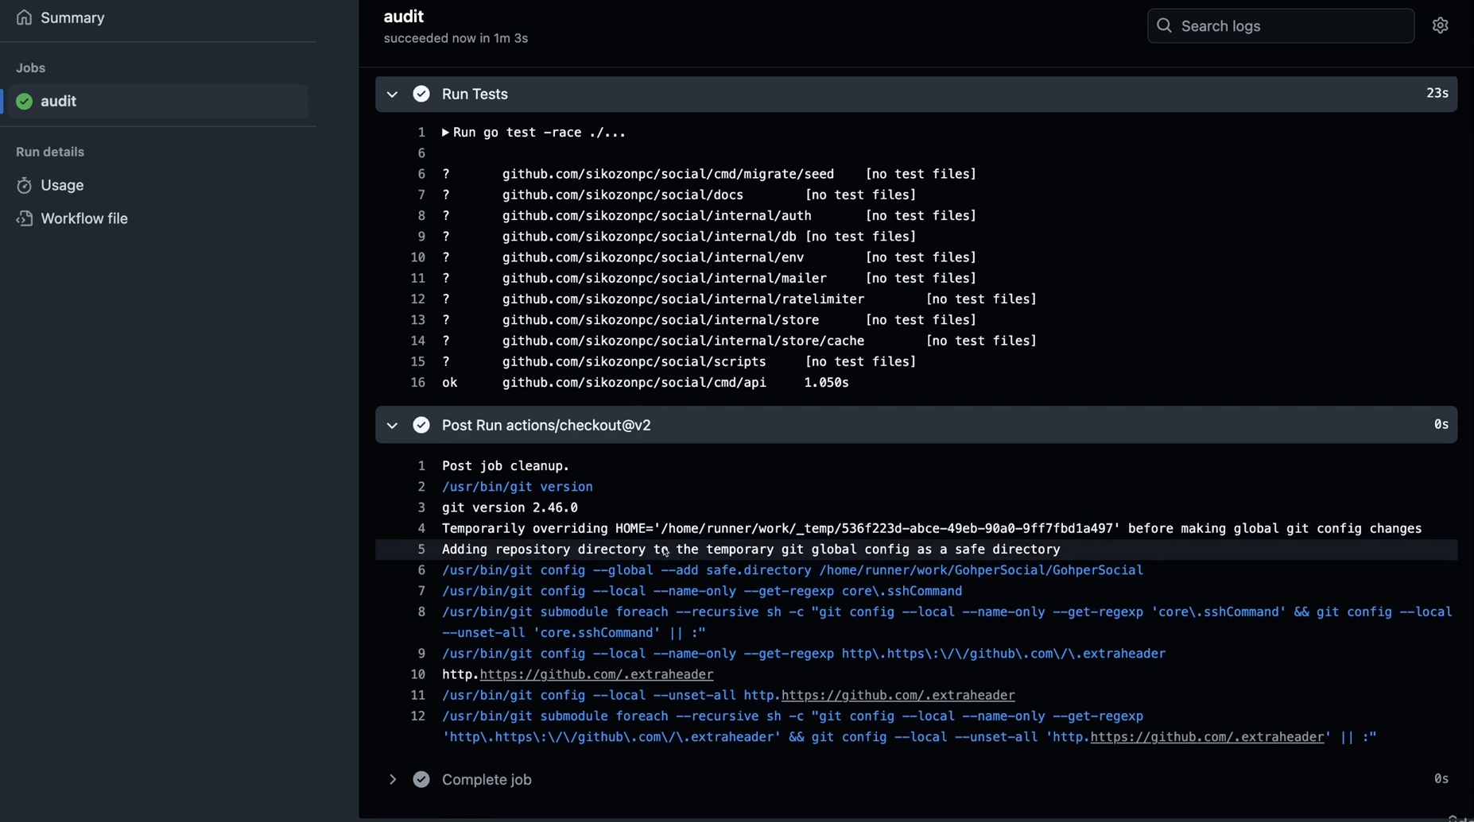

Let me actually do a git. So there we go. Our job is complete. You can see that all of the tests have passed. Now you can see all the tests we've written. They are okay. And then we have finished our process. If you have copy pasted from the course material, this whole audit script, then you're not going to have this problem. It's just going to pass at the first try.

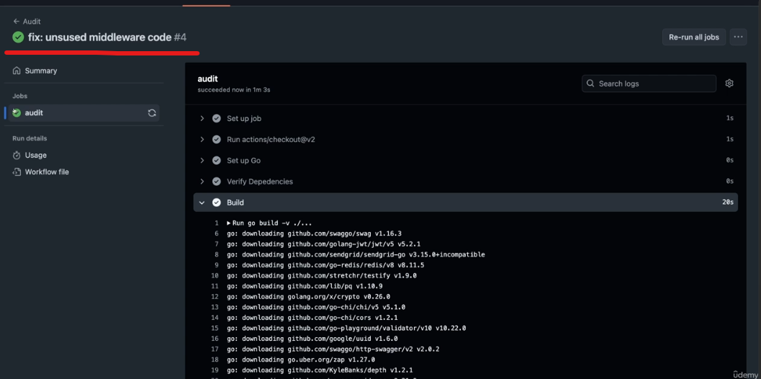

So let's go back here. You can see that the fix is already with the green symbol. So it is working. Now we have as some sort of a CI integration into our group for social projects. We are more confident in the code that we push to production. The next step is to actually increment the version and add some sort of changelog and versioning to our project.

Part 2- versioning and change log

So whenever this happens and the build has passed and later on we're going to also create an image and all of that. But what we need to do even before this is to create a versioning to our API so that we don't introduce breaking changes into the projects if we implement something that implements breaking changes.

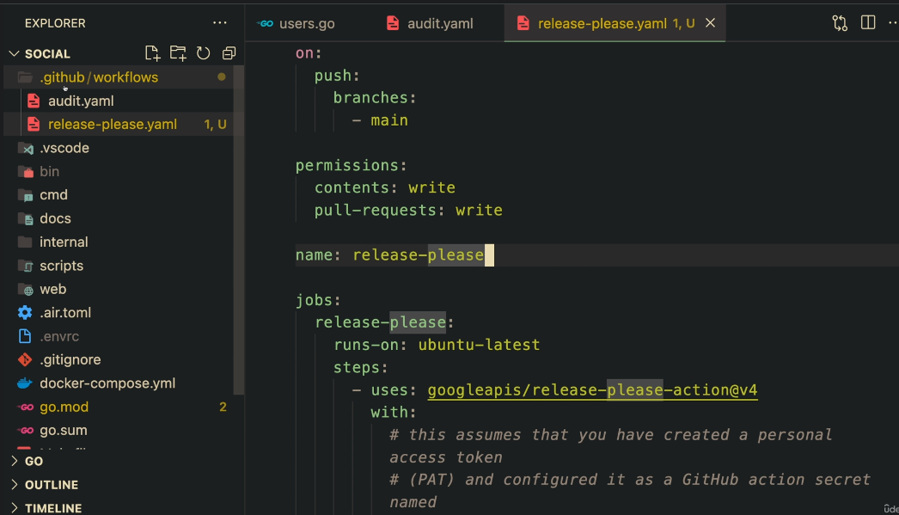

So what I mean by this is that we are going to create another action, which I have just typed it out here. it's called release please. That's what's going to happen, is that you can create as many actions as you want. They're going to start running, um, whenever you push or whatever you do here.

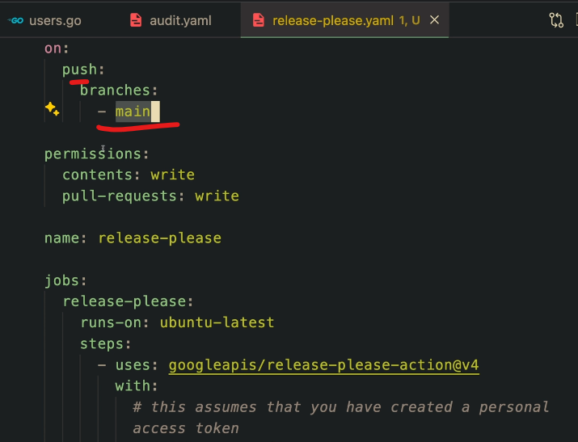

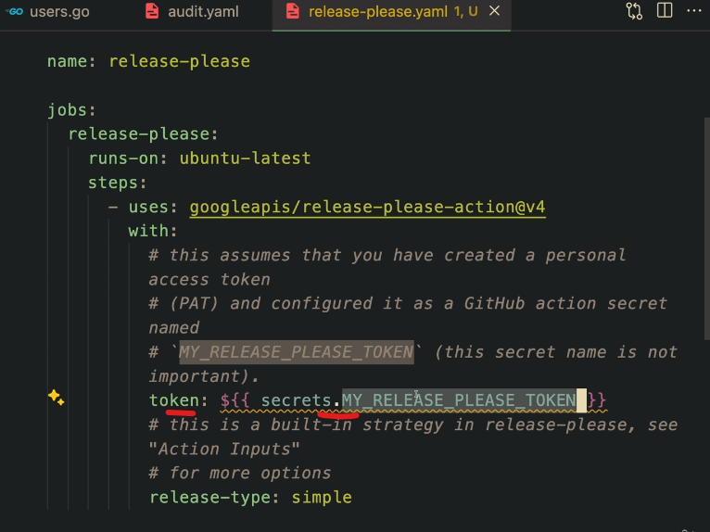

For example, this runs on push, this runs as well on push on the branches main. So whenever something is merged we're going to have basically this script running. And this requires these two permissions, which I'm going to show you how you can set up all of these.

That is because we need a secrets that I'm going to also teach you how you can create one secret to your project. Because this action here from the Google APIs release, please. What is this?

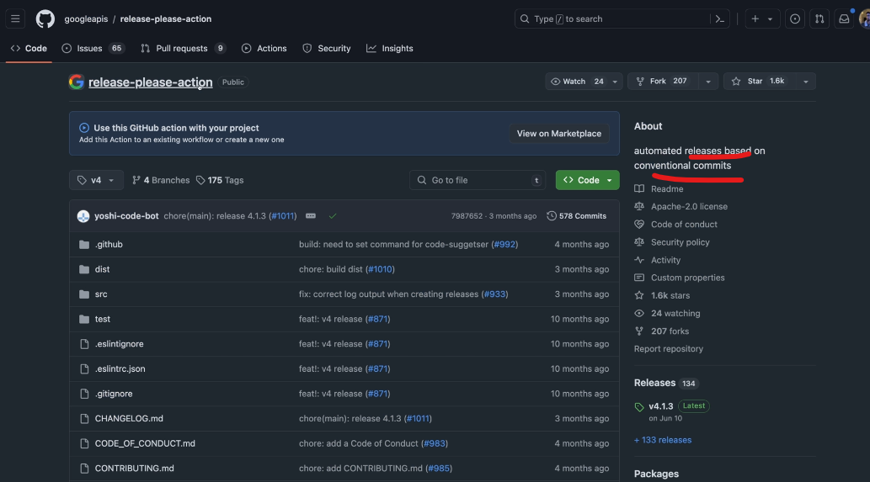

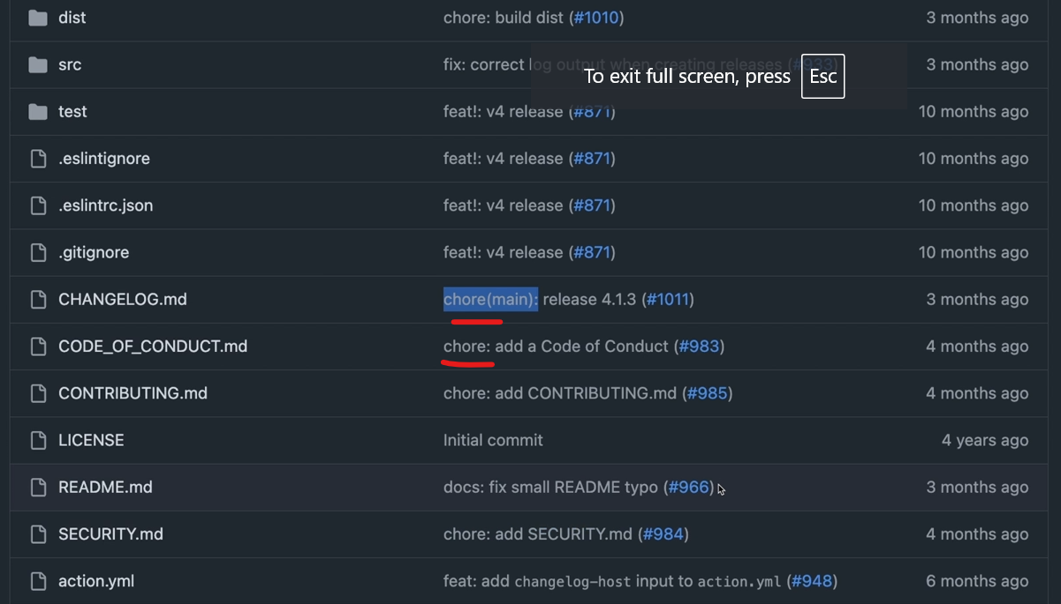

It's basically this action from Google. And this follows the **conventional commits that I have been using. And this is what it looks like the features, the chart and all of that.** I'm going to give you the specification as well if you want to follow along.

Q Why is this.

This is so that we have a convention so that we **have some structure for us to create a changelog that we can present to our stakeholders. And not only that, but to have a history of all the changes that happen on the application and also have an automatic version bump from that**. So if all of this doesn't make sense, follow along. I think it's going to make more sense then.

https://www.conventionalcommits.org/en/v1.0.0/

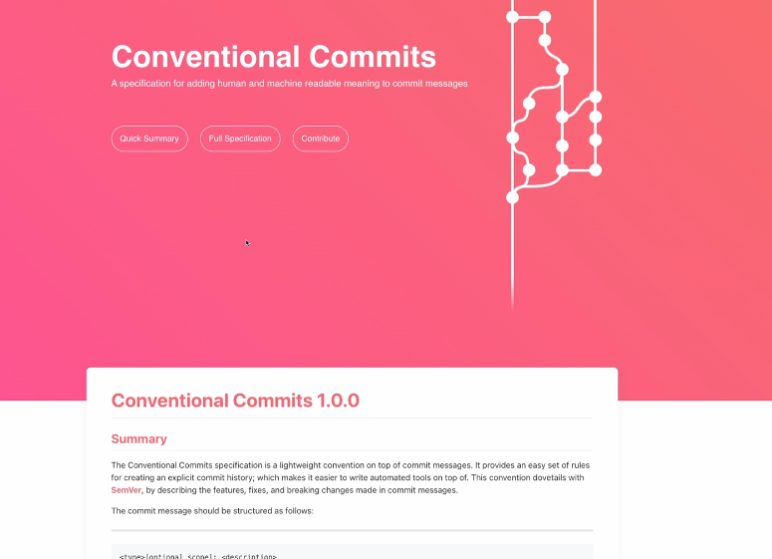

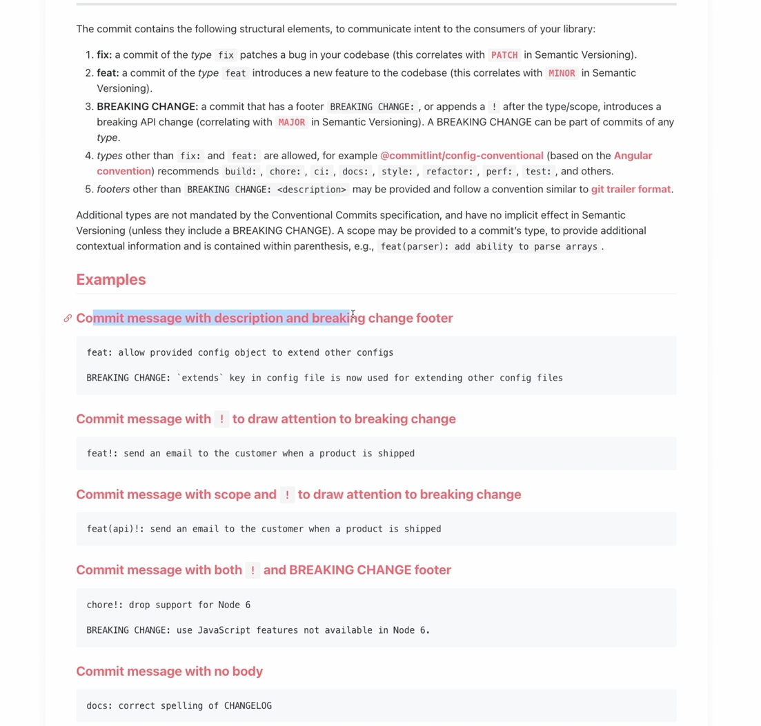

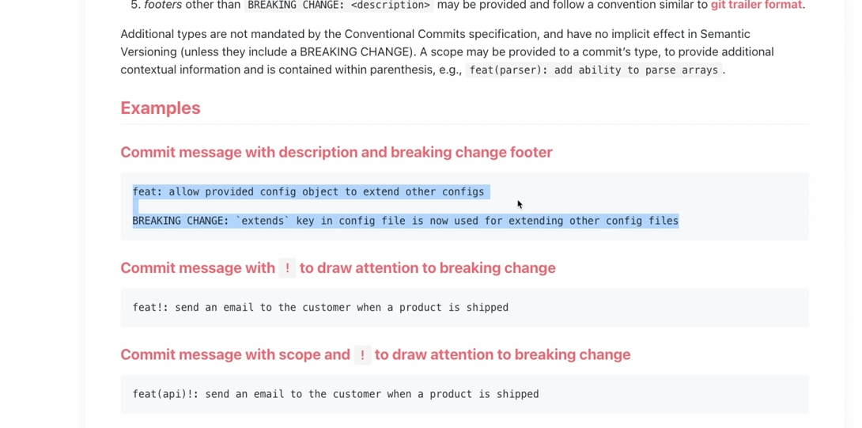

And this is basically the conventional commits website. And they specify all of that. Here you can see, for example, this is a commit message with a description and a breaking change footer. You can see that they add here the breaking change.

And then what's going to happen is that that action is going to read off your commits, the new commits, and then it's going to create a version from that. So you don't need to worry about creating a version and all of that. You just need to follow along the convention.

It's going to feel natural to you. And then you can also use here the exclamation mark towards breaking change. And then that script is going to create a version for you.

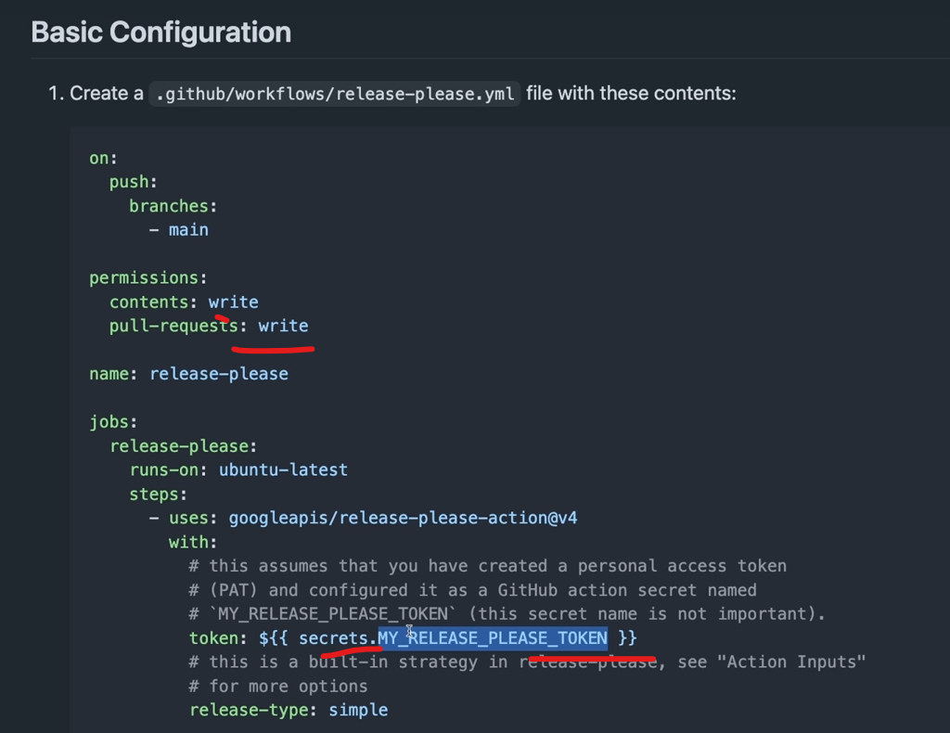

So the first thing is after we have just added this to our project and commits, and before doing that, what I'm going to do is that I'm going to show you how we can set up this token into our project, because this requires **some permissions to create contents and pull requests, because after one we're going to create another action, which is going to come here to our project, and it's going to increment the version A in our source code.** It's going to create a pull request that we need to accept, and it's going to do all of that for us.

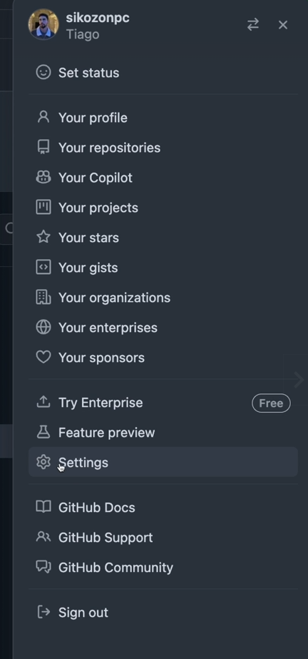

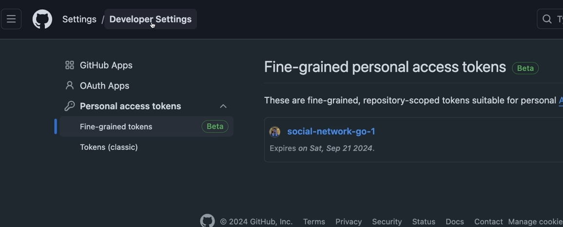

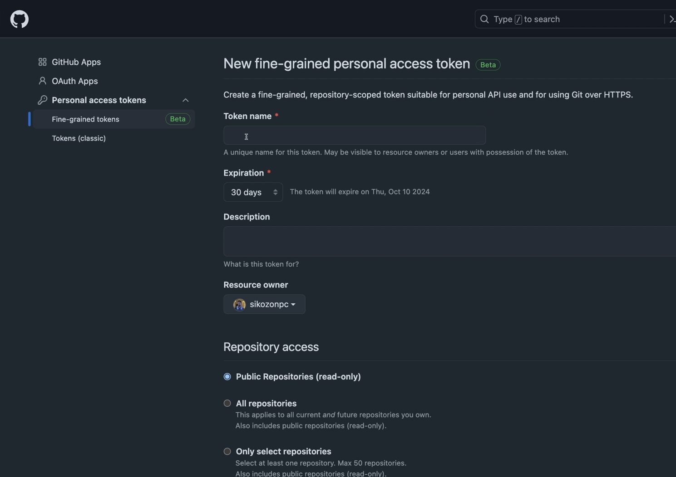

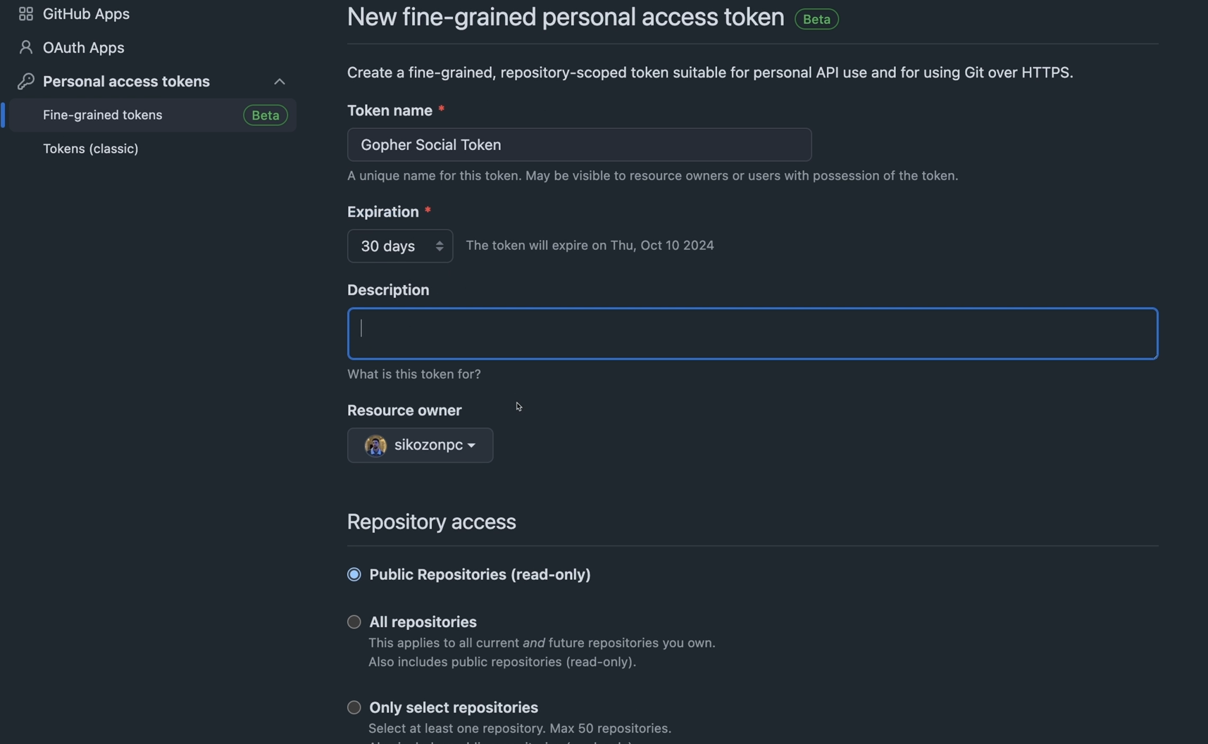

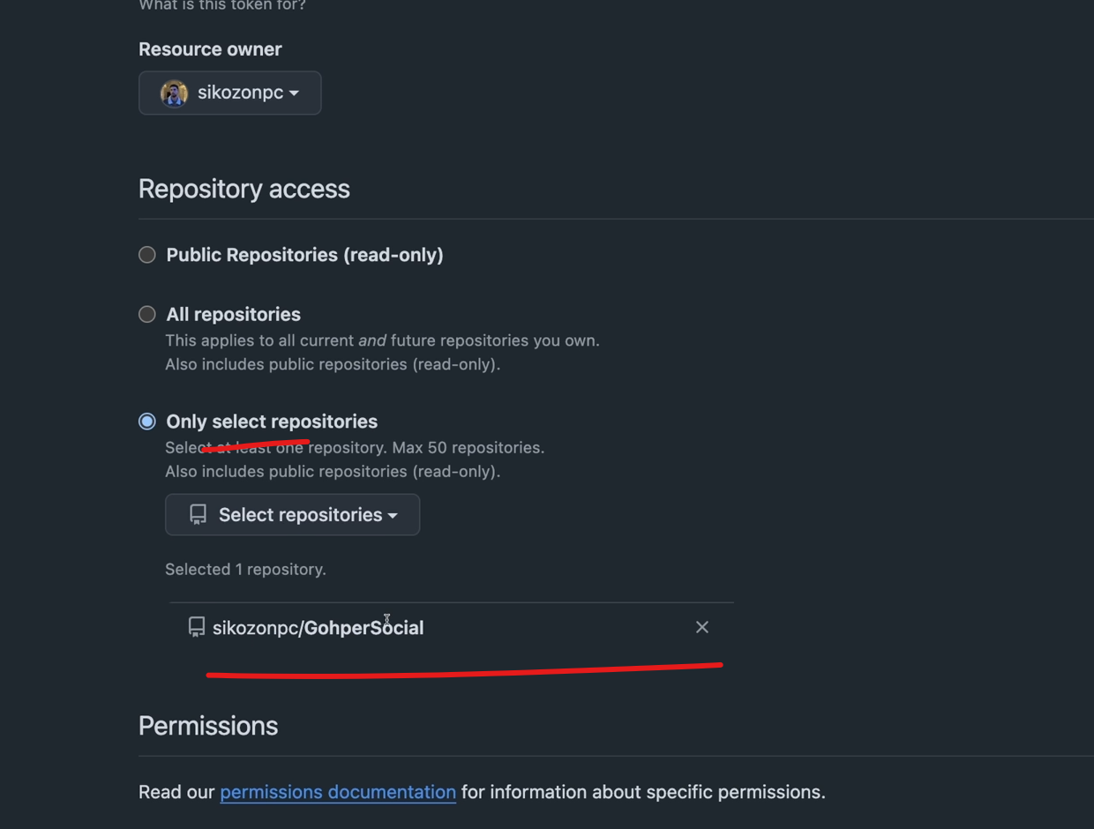

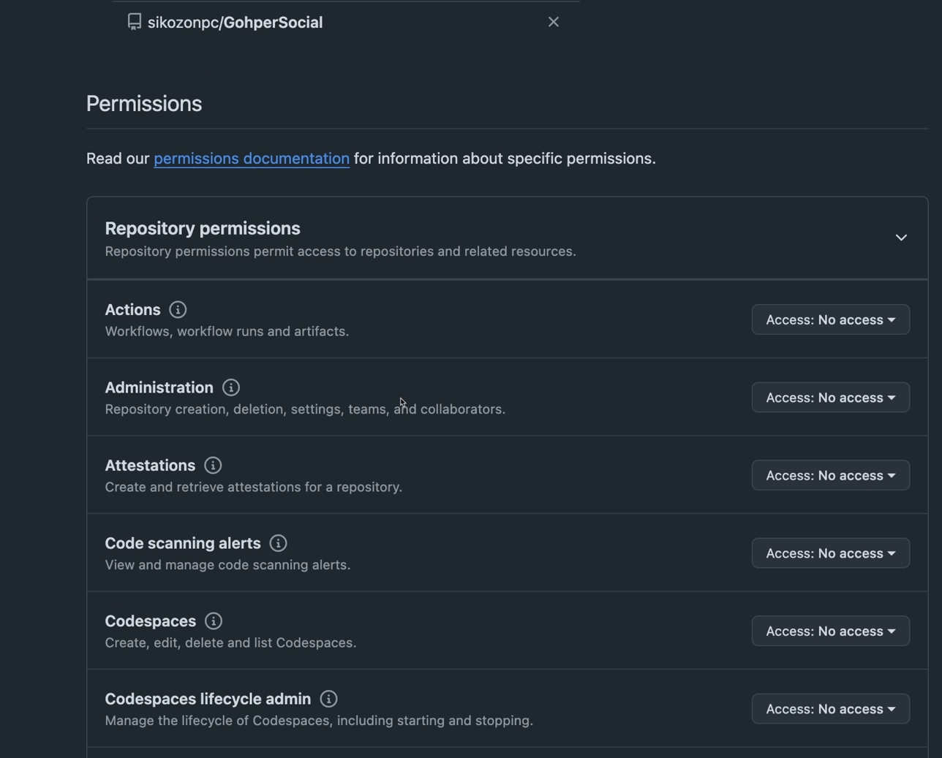

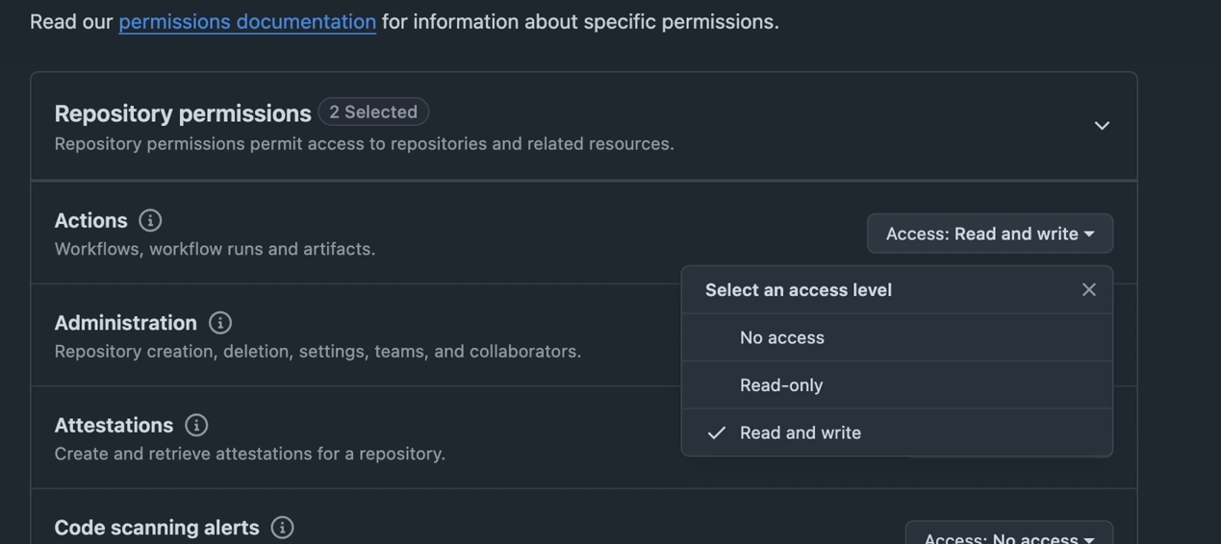

So what you need to do is come here to your profile and then click on the settings right here. Then once you are on settings click on Developer Settings. Then you're going to be sent to this page here. And click on the fine grained tokens. And let's generate a new token. So specify here a name for it. For example I'm going to call it gopher social token and then add some explanation. I'm going to do for example 30 days or like 90 days.

And you can auto generate this token is pretty easy or you can add a custom expiration date. Here I'm going to do for example 30 days. For now you can add a description if you want. Then the important thing is that we should select the repositories that we want. So select the gopher social project that we have that we're working on. So I have selected mine.

Then let's go into repository permissions. And we need to allow some permissions to run. So the first thing is set up access to the actions permissions. So to have read and write.

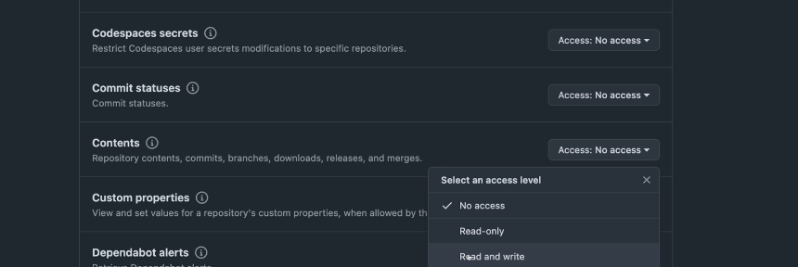

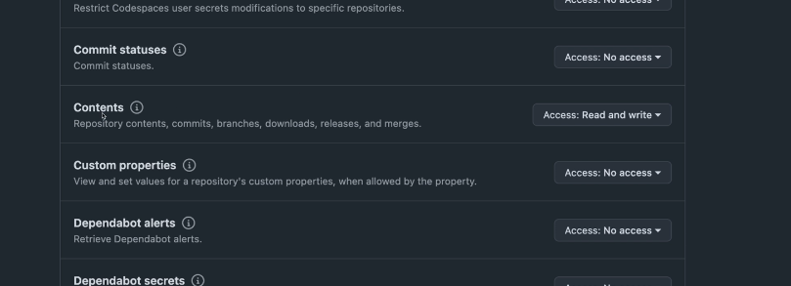

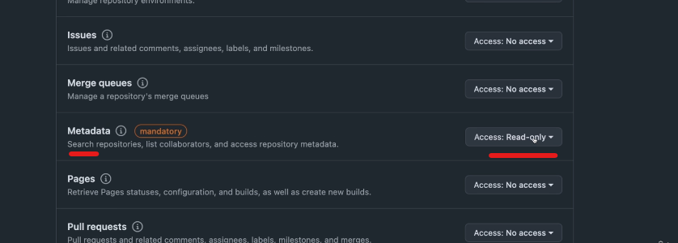

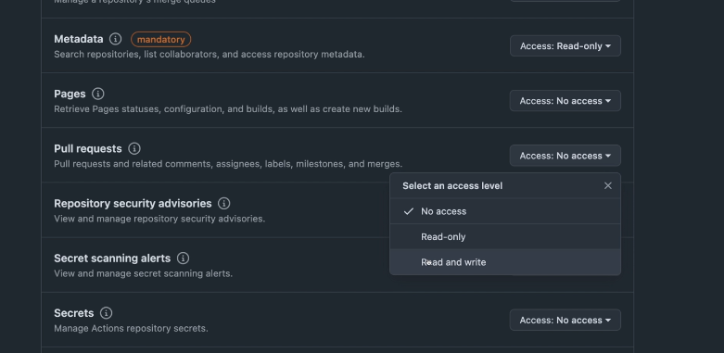

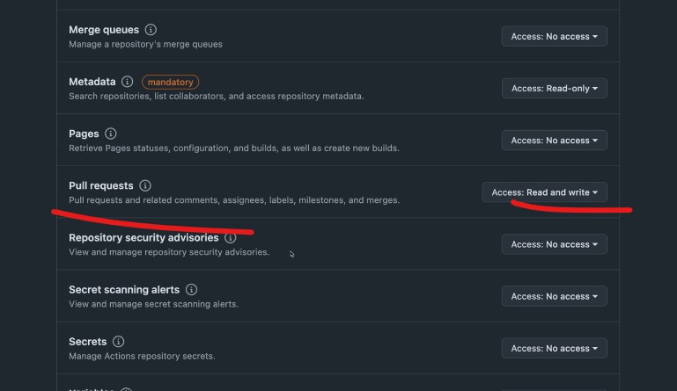

Then let's scroll down below. Let's also give read and write permissions to the contents. Because we're going to be updating our codes and branches and offsets. Then the metadata it is mandatory. So we already have read only. Then the last one is the pull requests which we're going to allow this consumer to create pull requests. So let's add the right permission as well. And that is pretty much it. If we have any errors you can come here and update it.

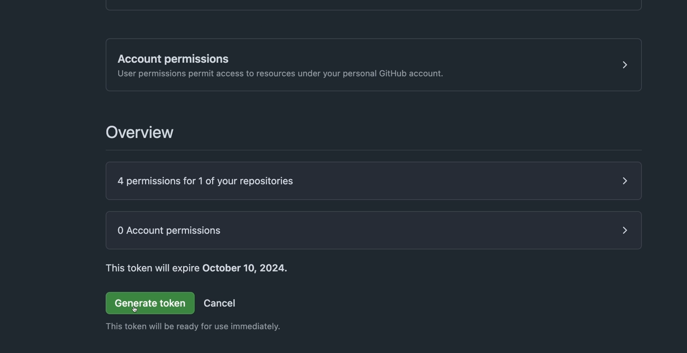

But for now let's generate this token. So I have just copied that token to your clipboard. You should store it somewhere. Don't share it with anyone because they can have access to your project after that. So what you're going to do after is go to your group for social project or whatever project you have named.

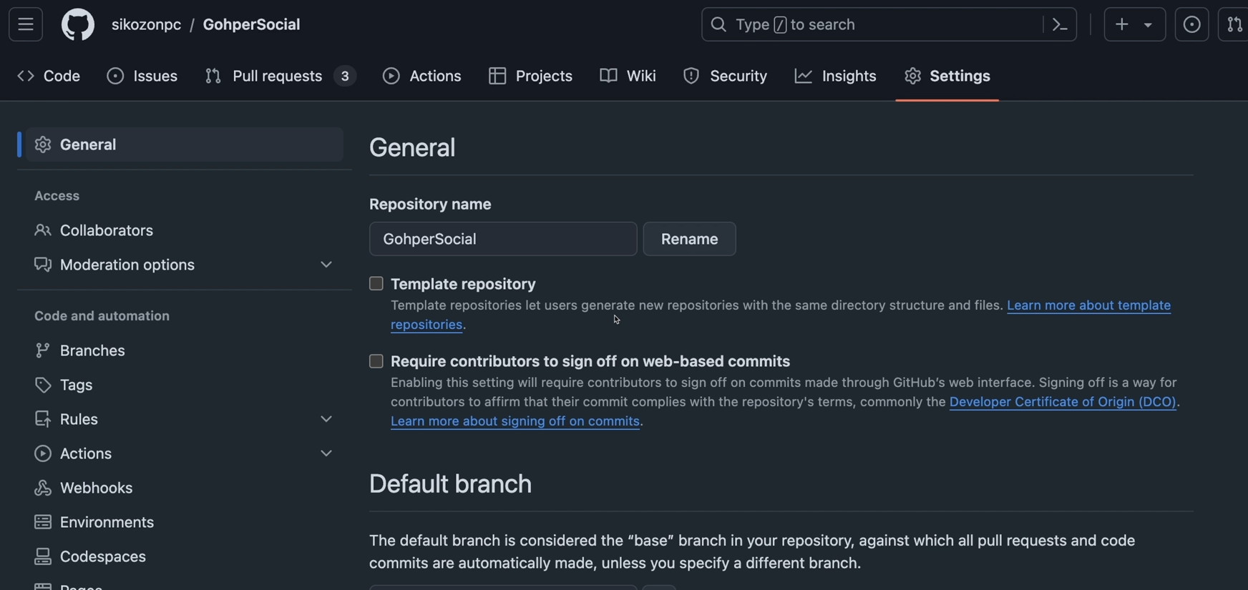

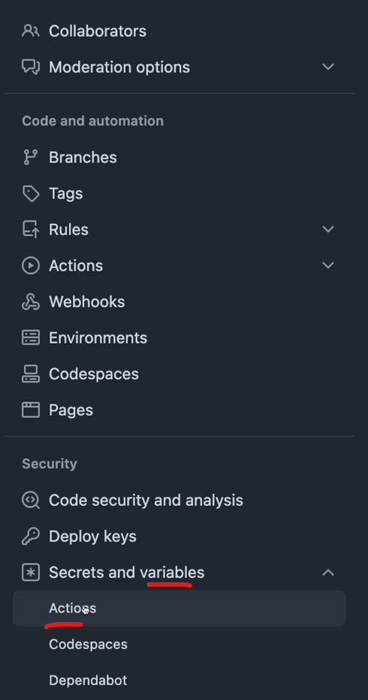

But for now let's generate this token. So I have just copied that token to your clipboard. You should store it somewhere. Don't share it with anyone because they can have access to your project after that. So what you're going to do after is go to your group for social project or whatever project you have named. Go to the settings of that repository and then scroll down into secrets and Variables and click on the actions.

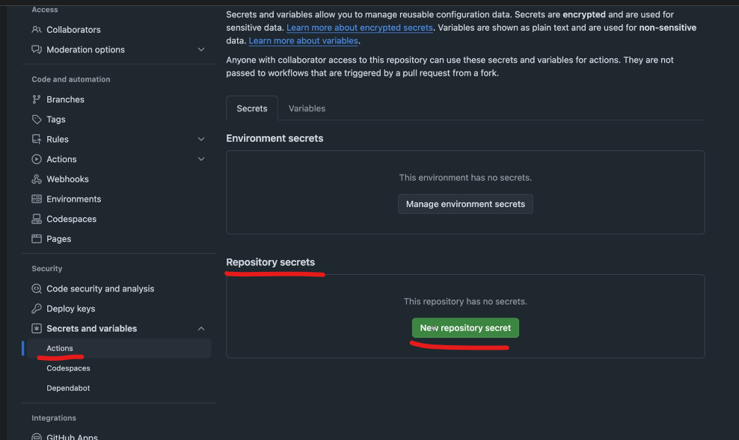

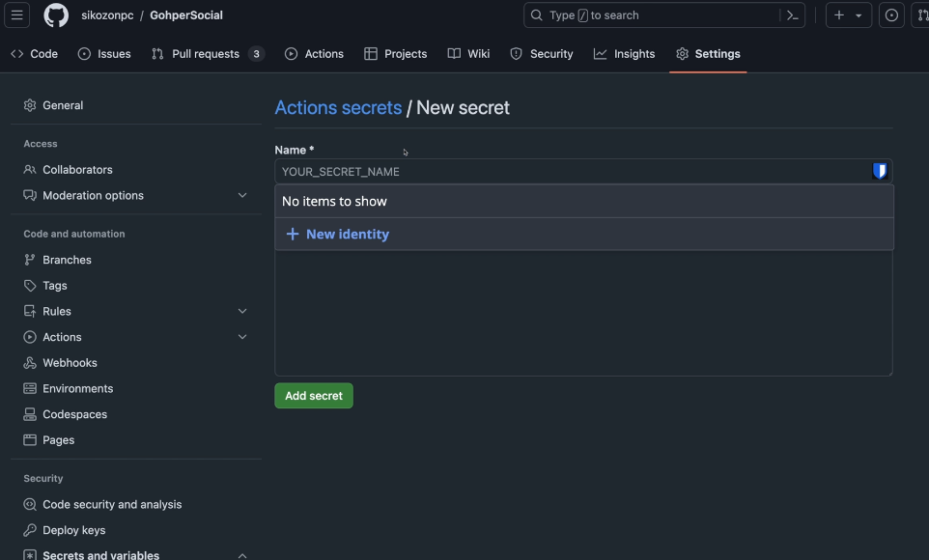

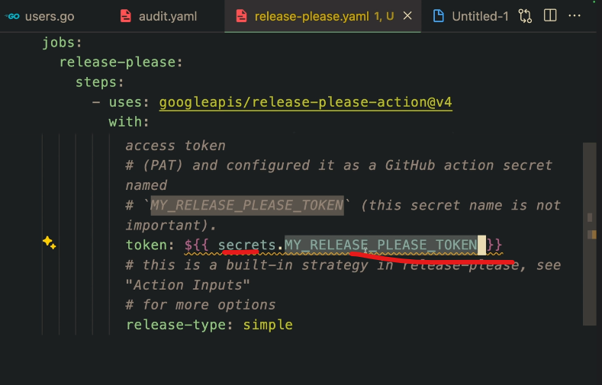

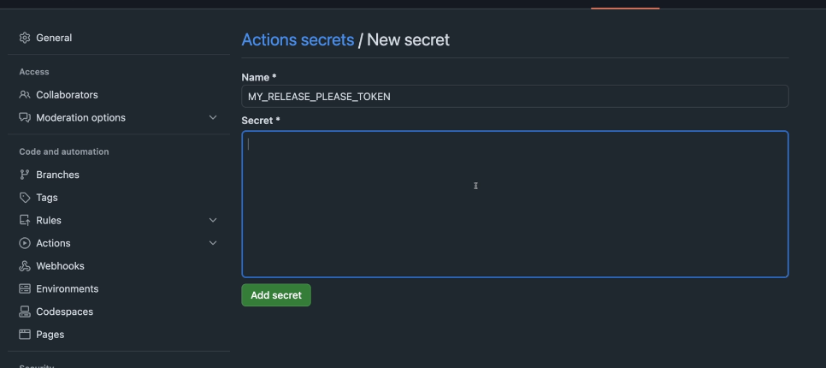

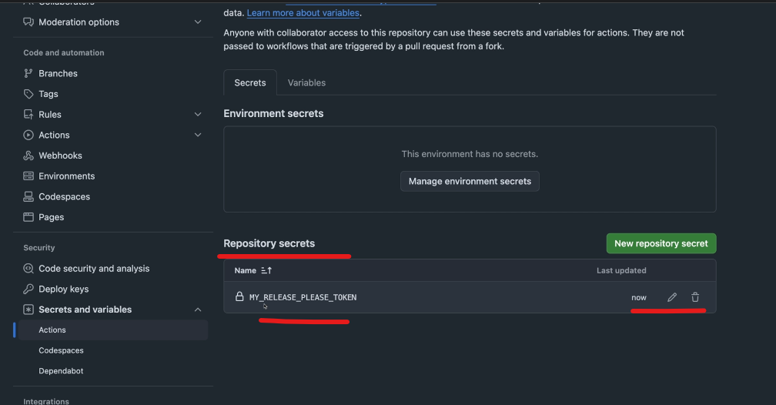

Now let's create a New. So what are you going to do is that you're going to come here to Repository secrets under the secrets and variables and actions. Let's create a new repository secrets. Now the name of this needs to be that name you have on your file. So secrets dot repository. So just add this part here. Then the secret is whatever you have copy and paste it. So make sure you store that before you copy and paste the My release string. Just copy paste here your token and click on Add Secrets. So after you've done that, you should have here a secret on your repository secrets. And now we can safely push our changes. So let's just do that.

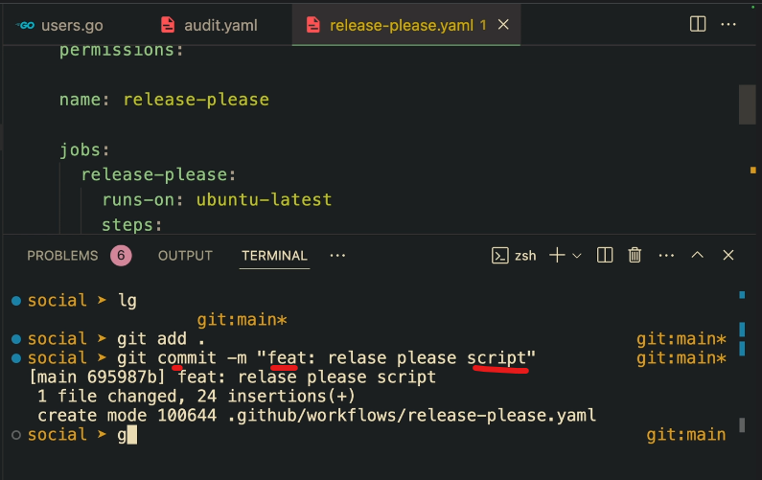

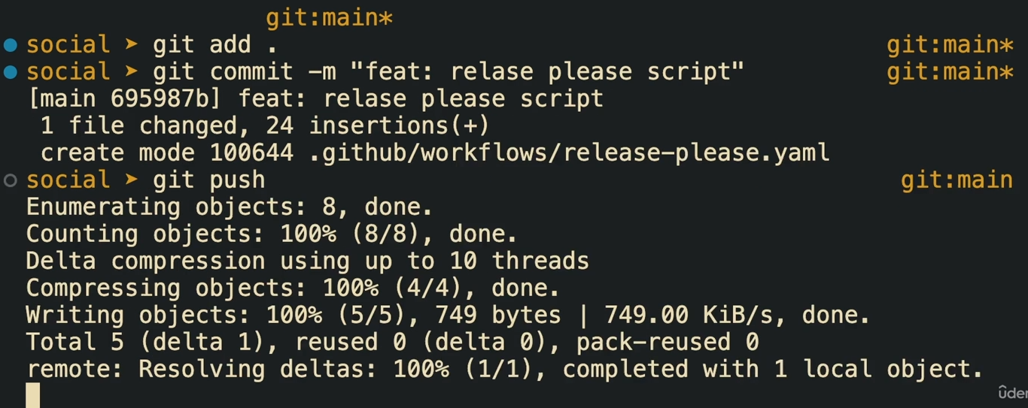

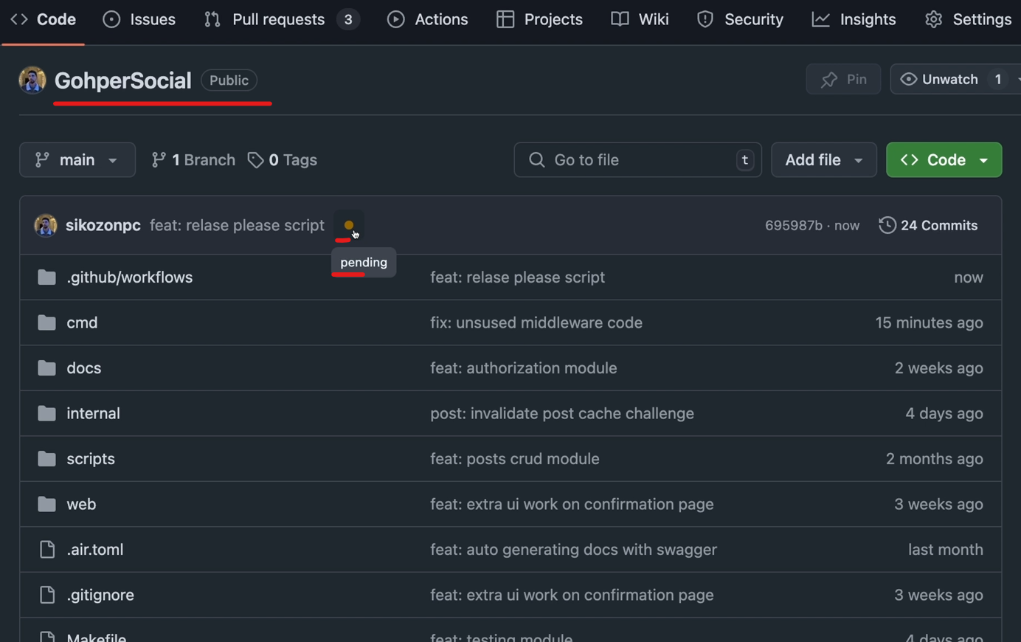

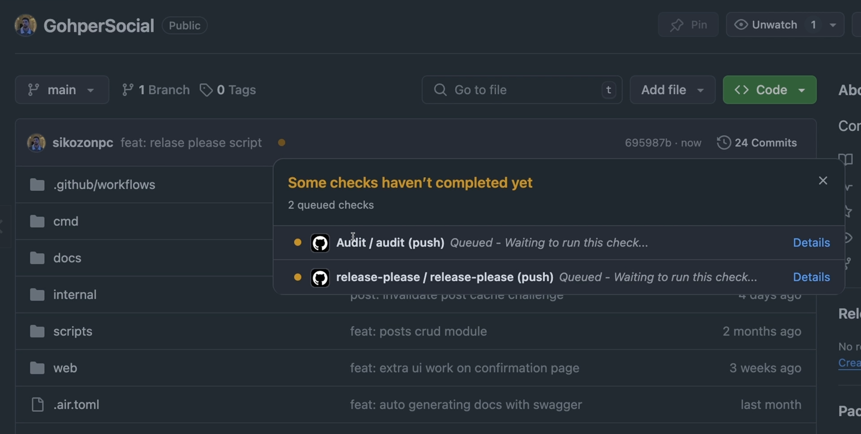

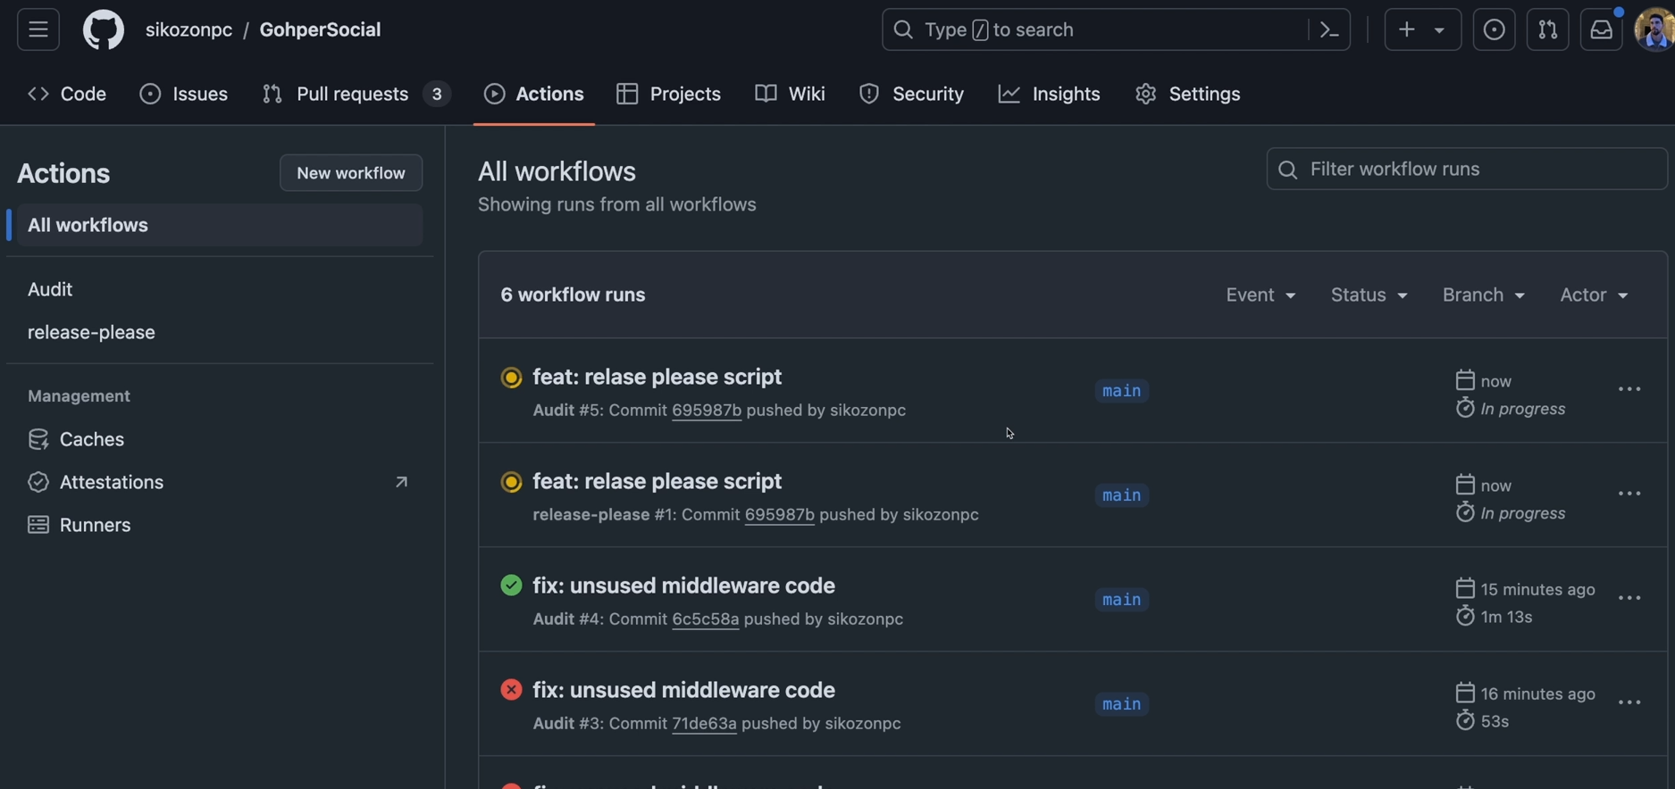

And so I'm going to call this commit for example fit which is going to add the feature which is the release with scripts. Let's git push and let's see what's going to happen. So if you go back to the code and click here on the pending, you can see that now we have two actions running at the same time. So let's go back to the actions.

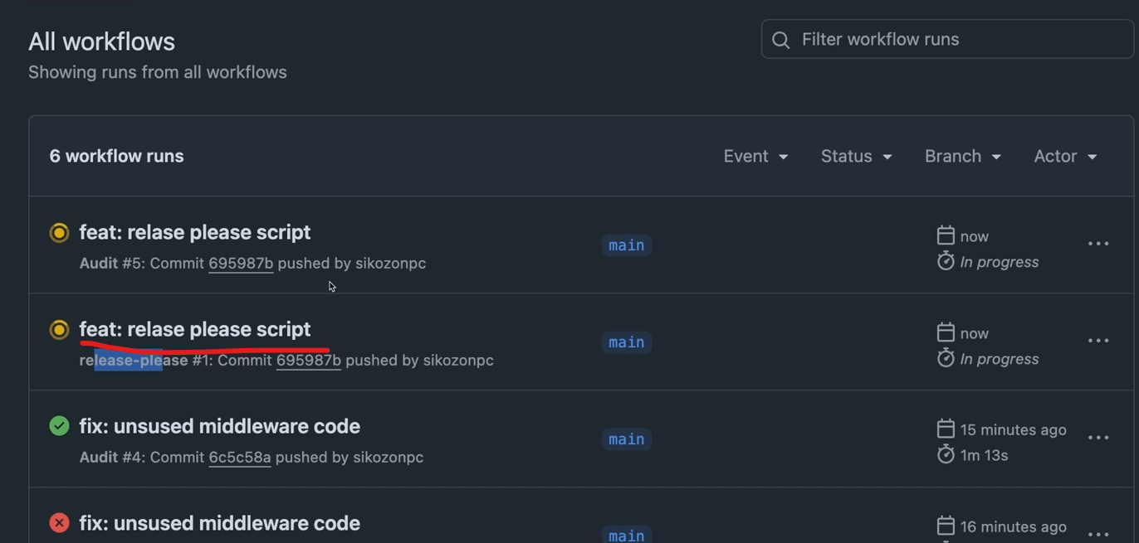

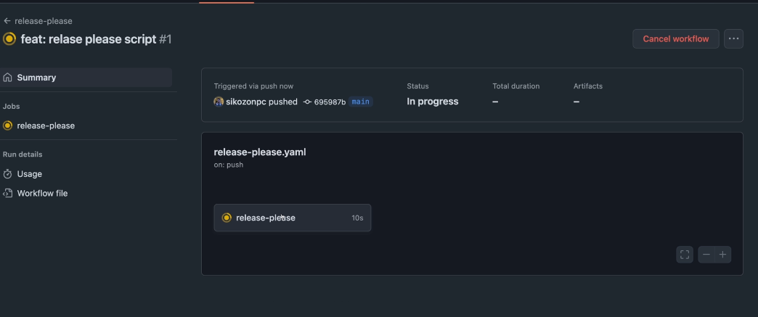

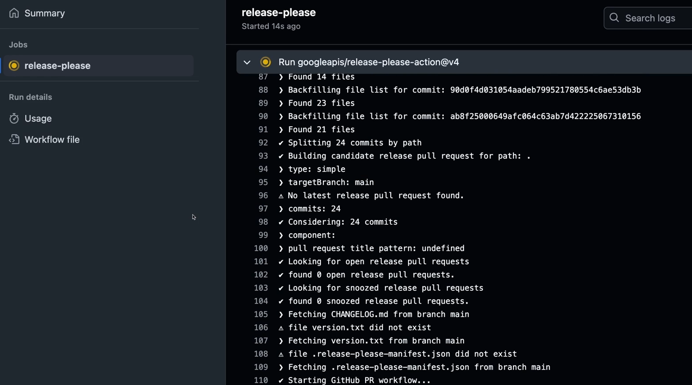

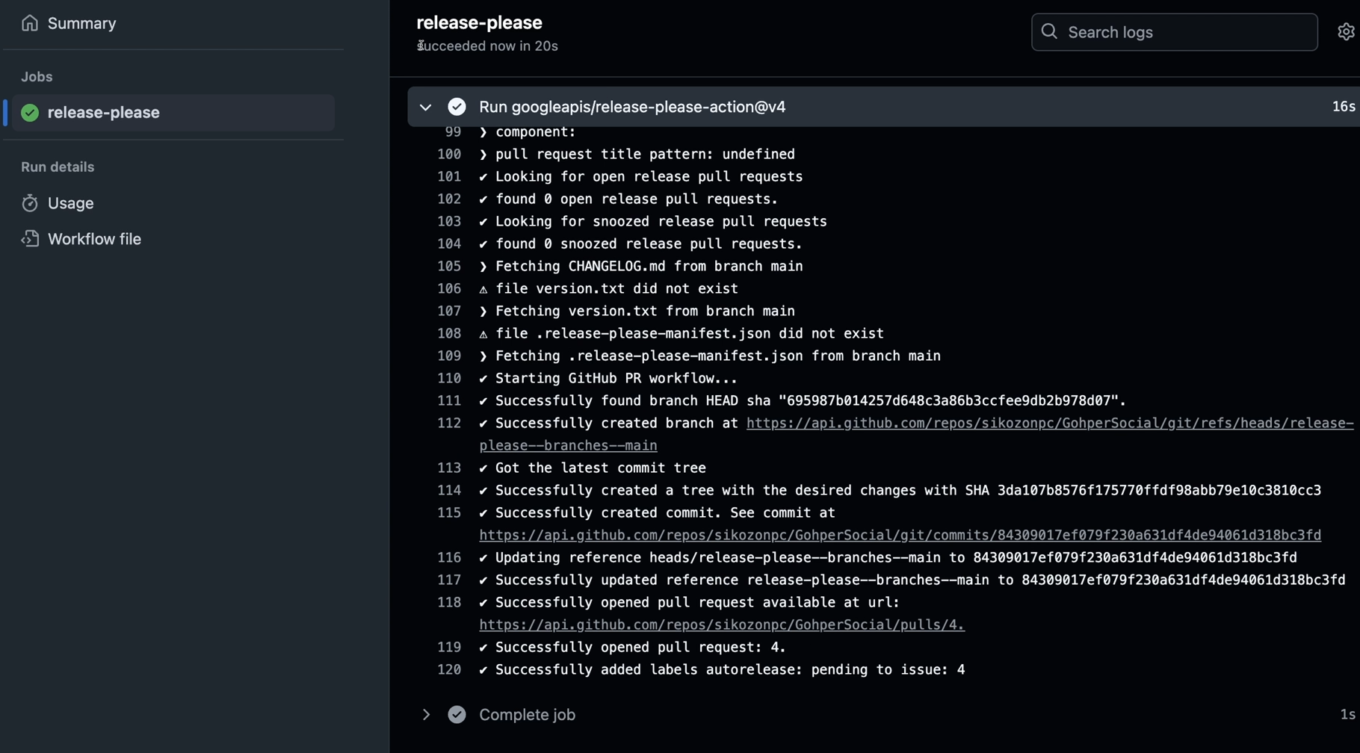

And let's click on the new one. Because the other one we have already seen. So this is the release is one. So let's click on this one. And as you can see it's doing a lot of stuff. Let's see what's going to happen at the end. So the job has been succeeded. It finished in 20s. And if you head back to your pull request, you should have here a pull request from that tool.

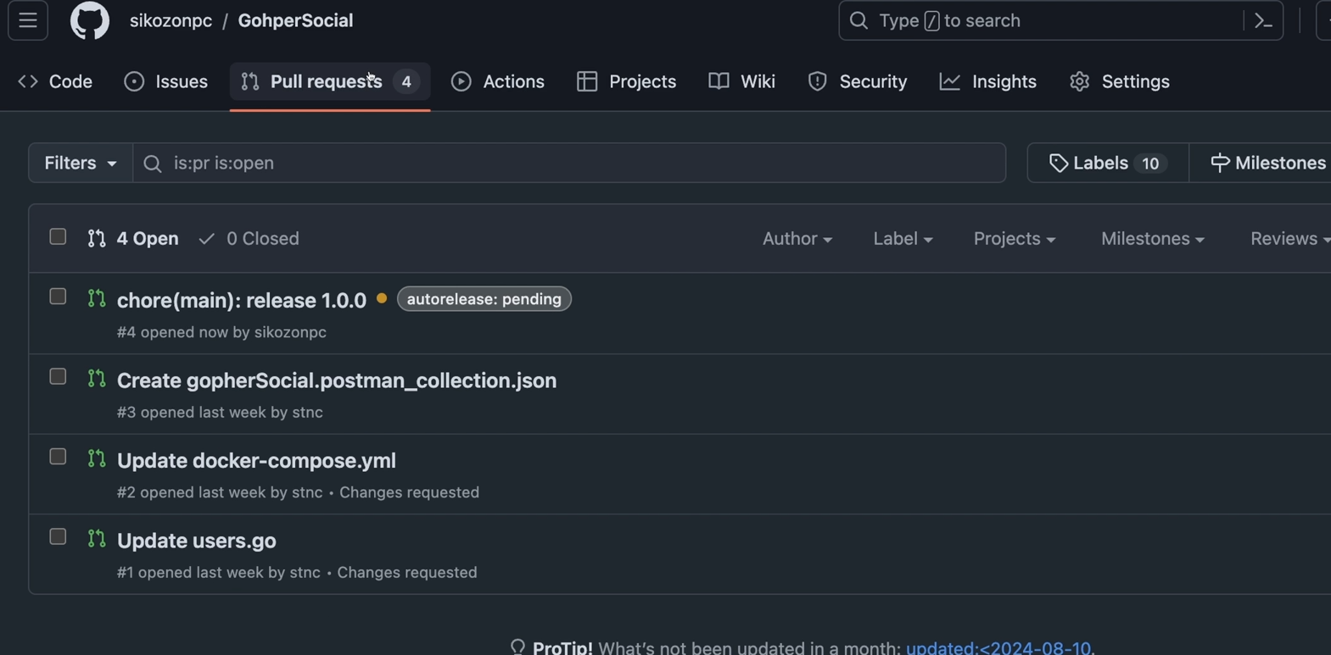

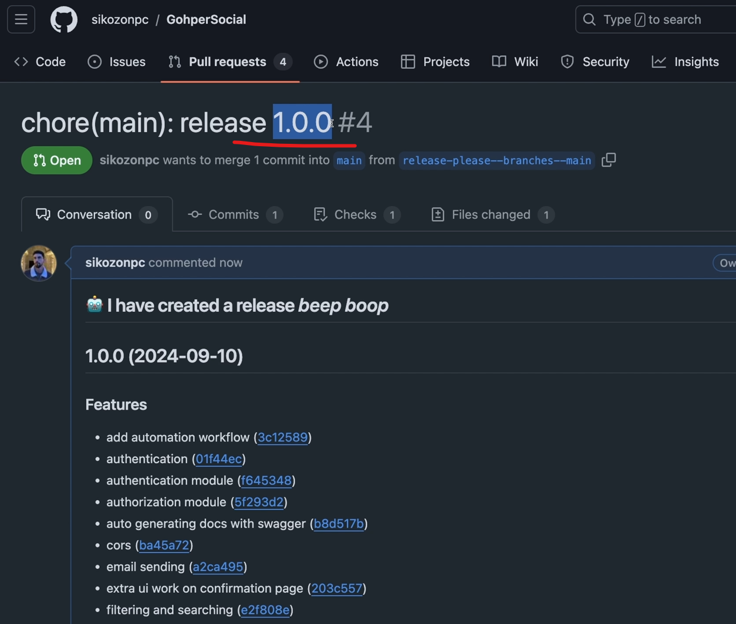

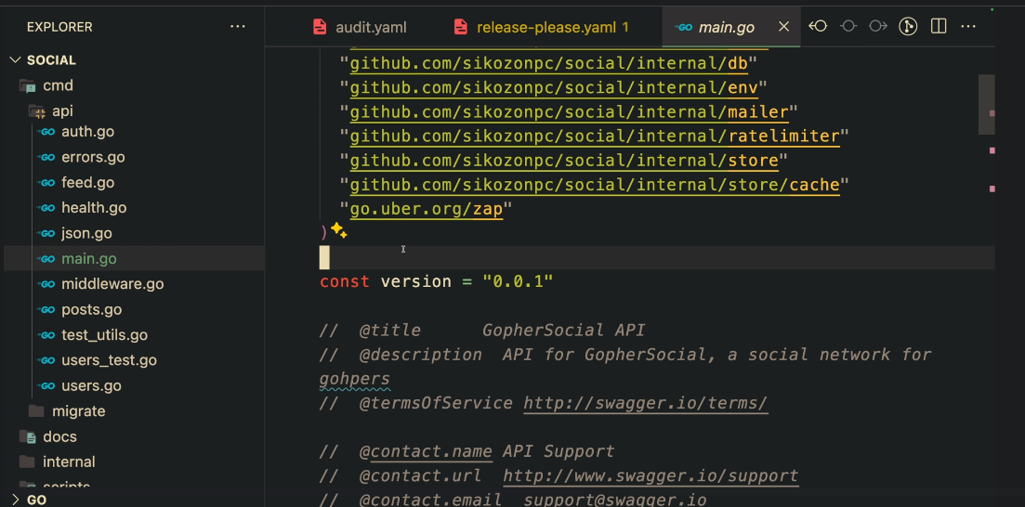

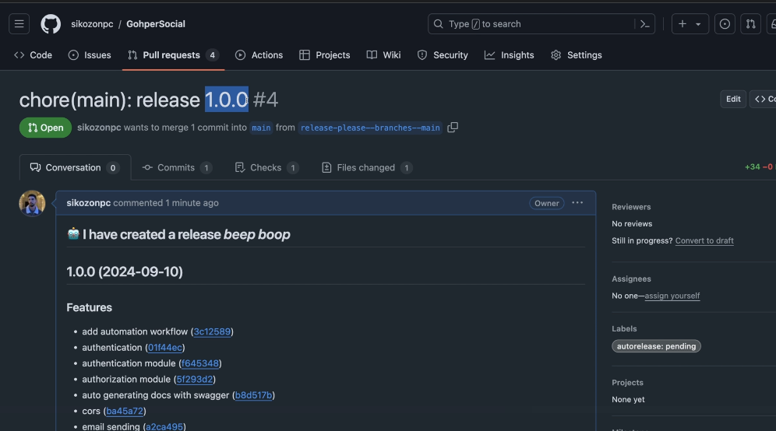

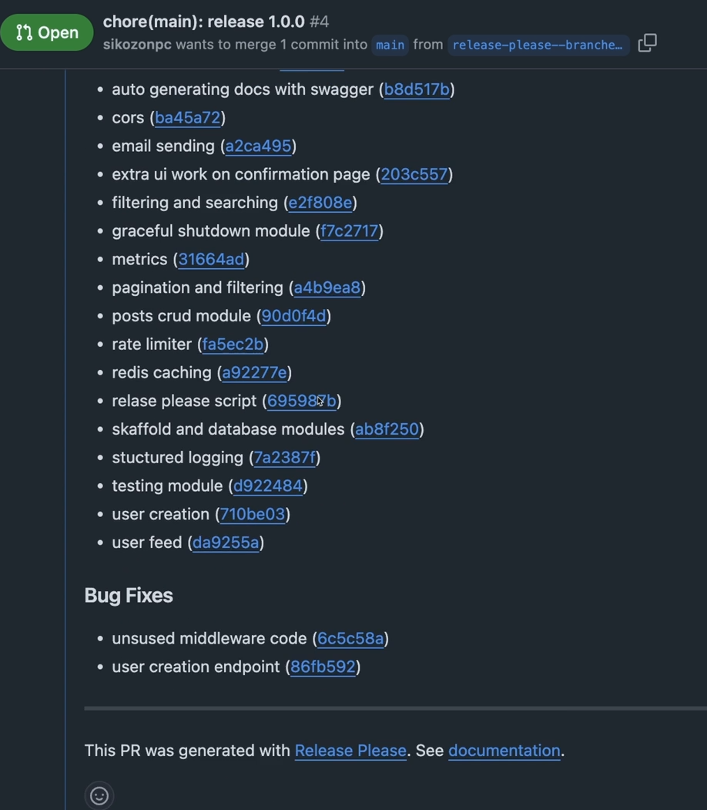

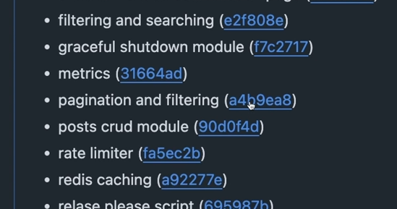

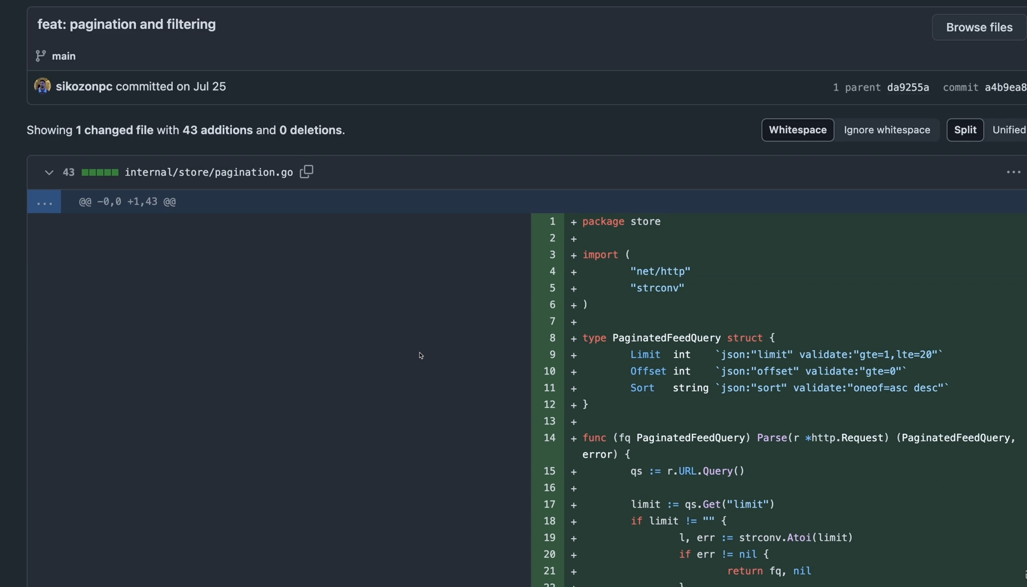

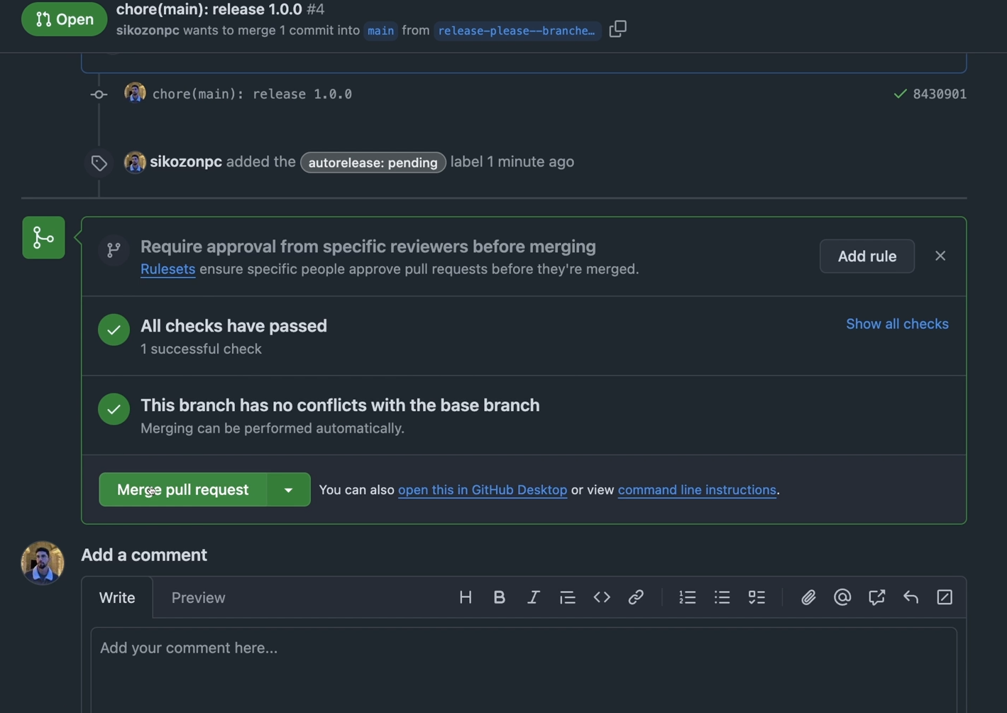

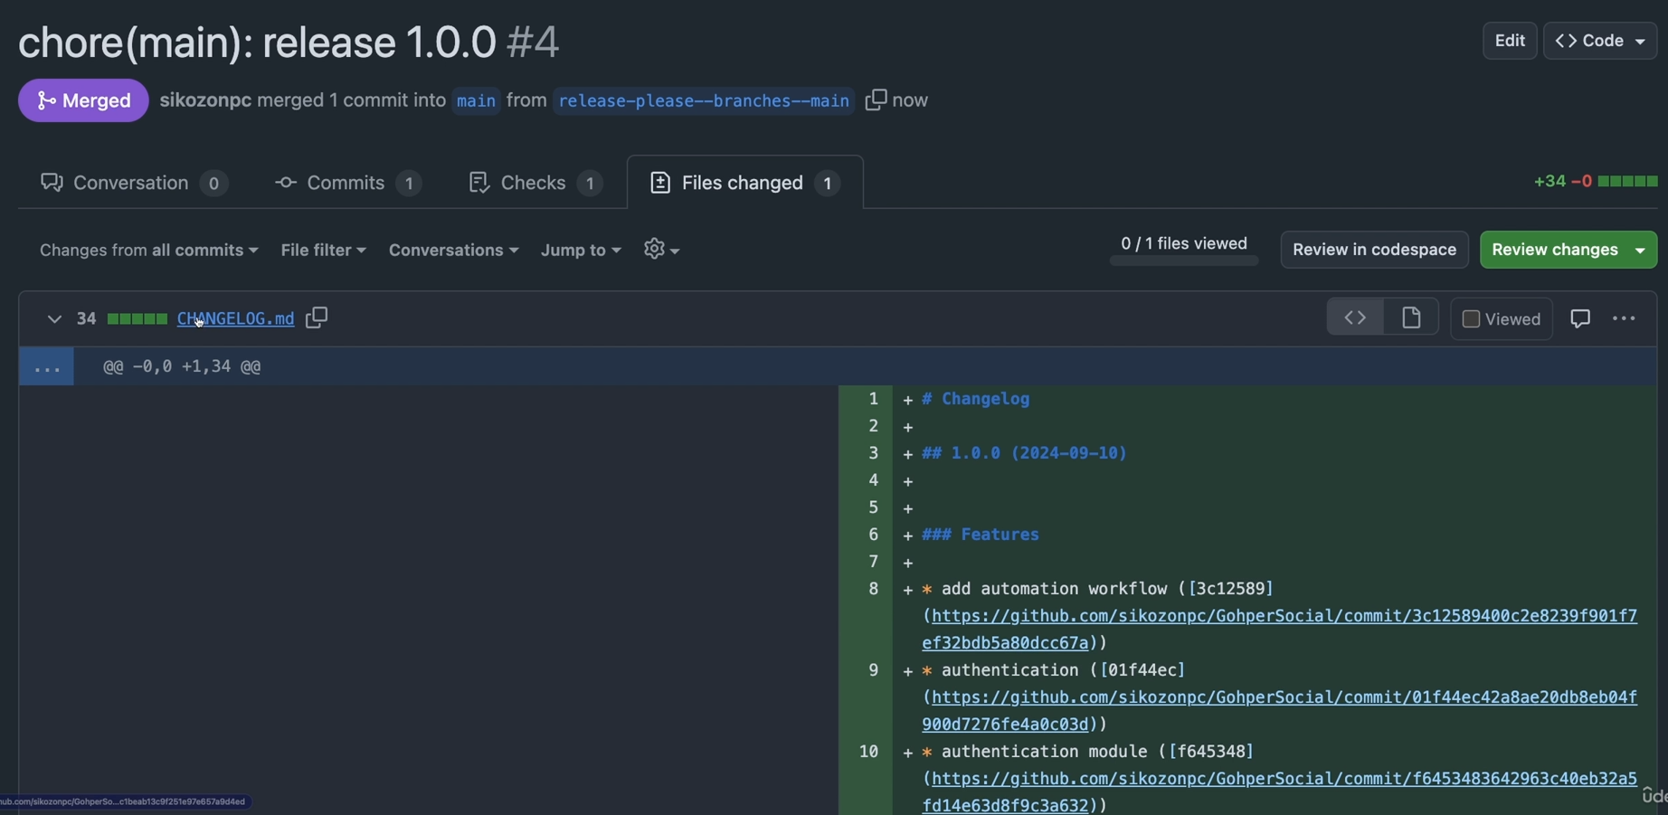

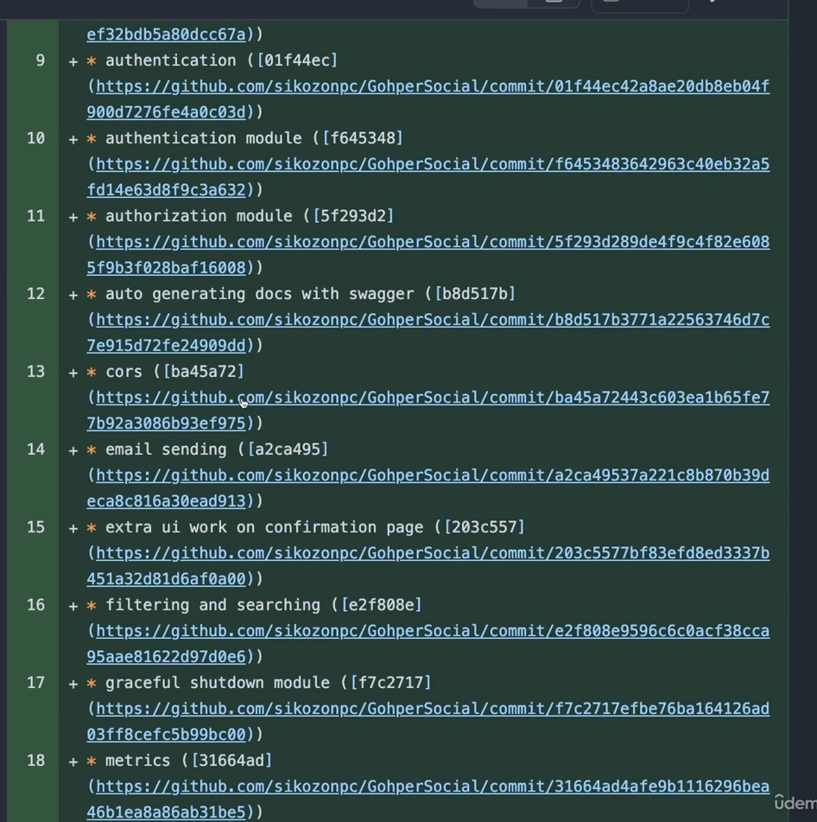

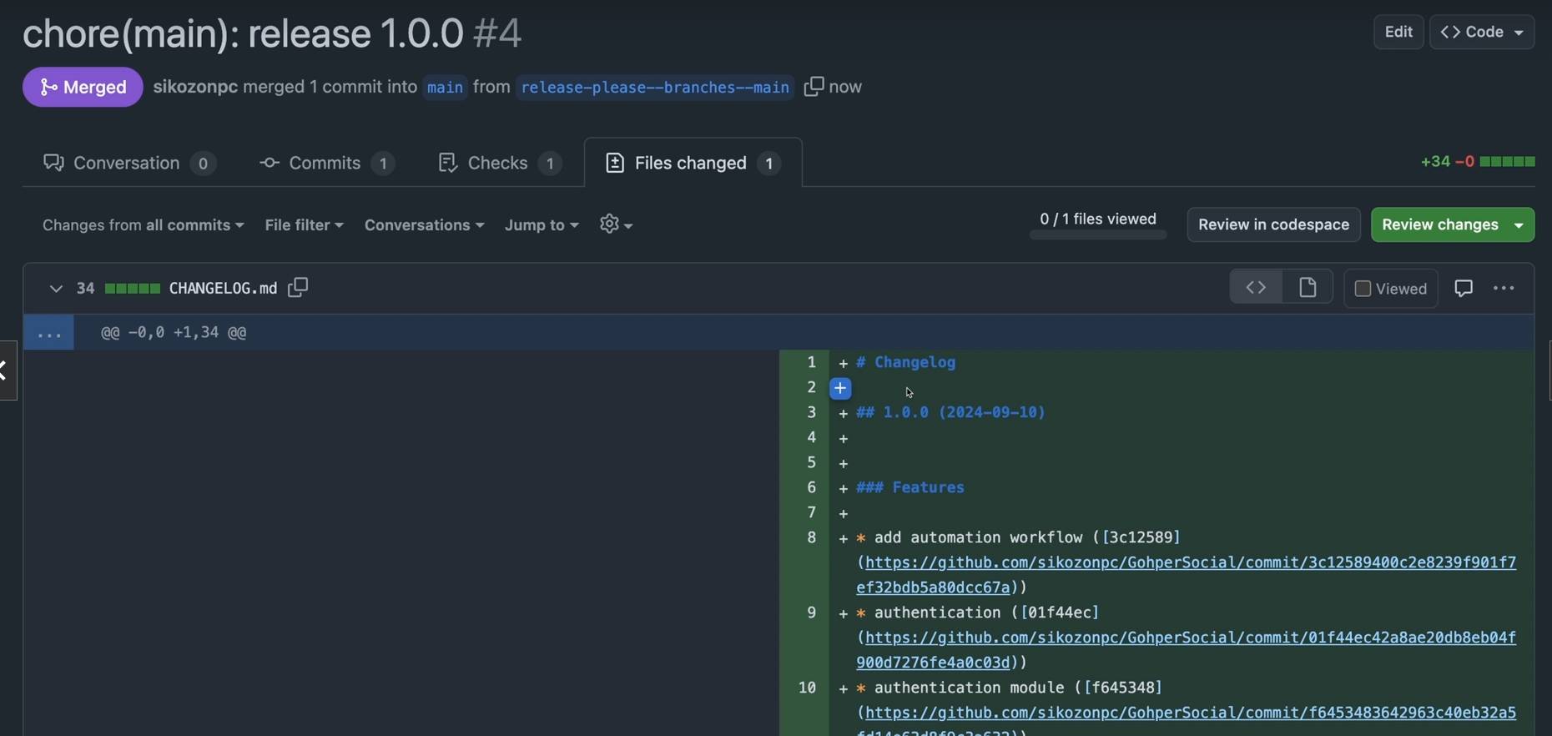

So here you have a release into 1.0.0. So this is our release version. Remember that a few minutes ago we were at the version 0.0.1. So we were on very early pre-release. And now this is our official 10.04.0 version. As you can see, this is the version or the changelogs of the whole course we have. Then this is the whole all of the modules that I have been committing. You can see, for example, all the work we did on the pagination and filtering. If you click on this, it says that commit that I have done with all those changes. So you can see what's happened at any specific time. So let's just merge this. Let's confirm the merge. And actually what happens here is that this created a new file called changelog dot markdown. With all of the changelog releases that is going to be appending here. So anytime you do another release to production, this is what's going to happen. It's going to run the script. It's going to create version changelog and you need to manually approve it. Or you can actually automate this to merge. But it's way safer that you click it once. And honestly, this is the only action that you need to do to deploy to production. After you click this, the whole shebang is going to happen that we're going to implement on the next video.

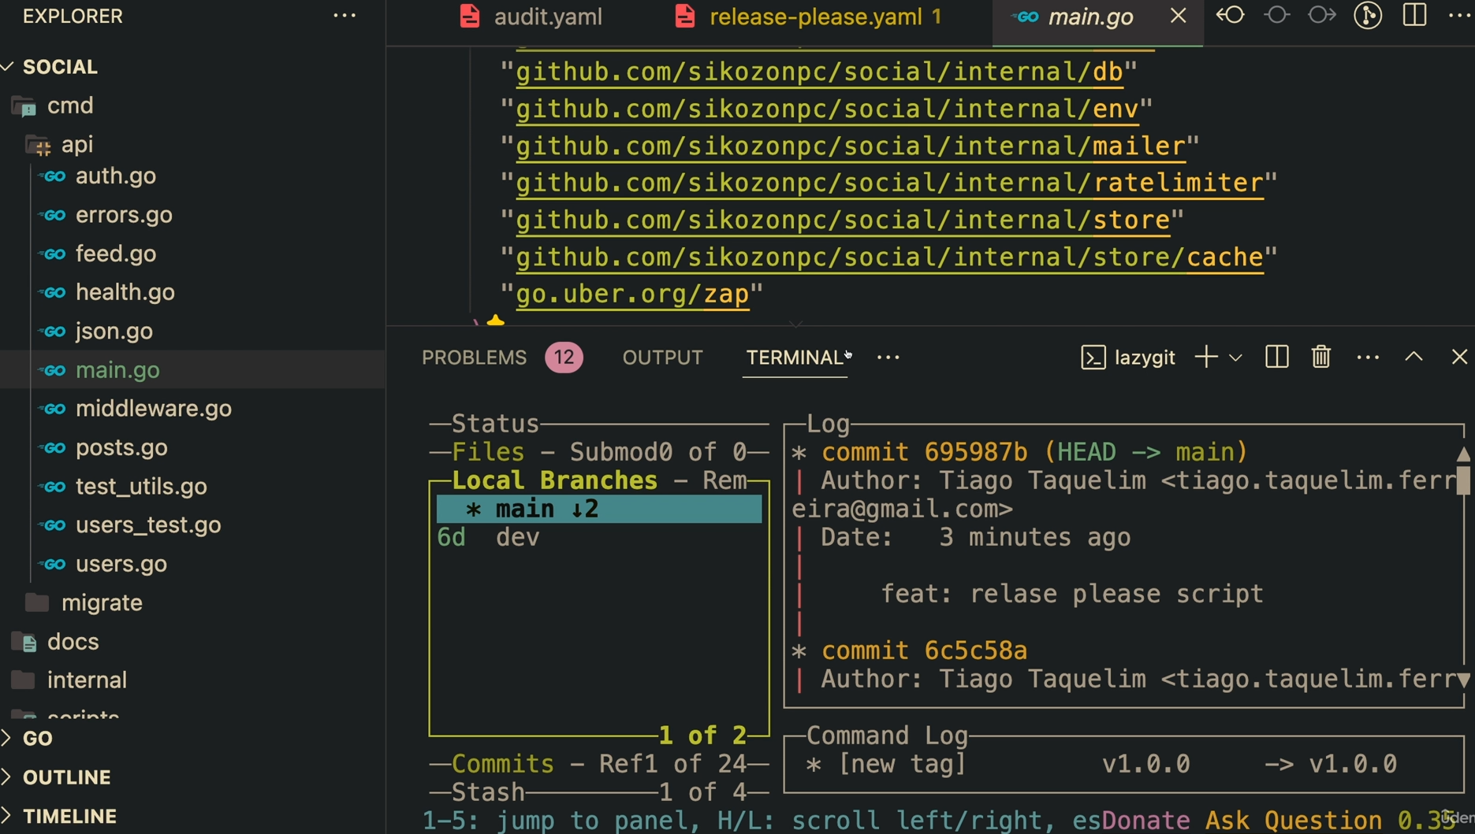

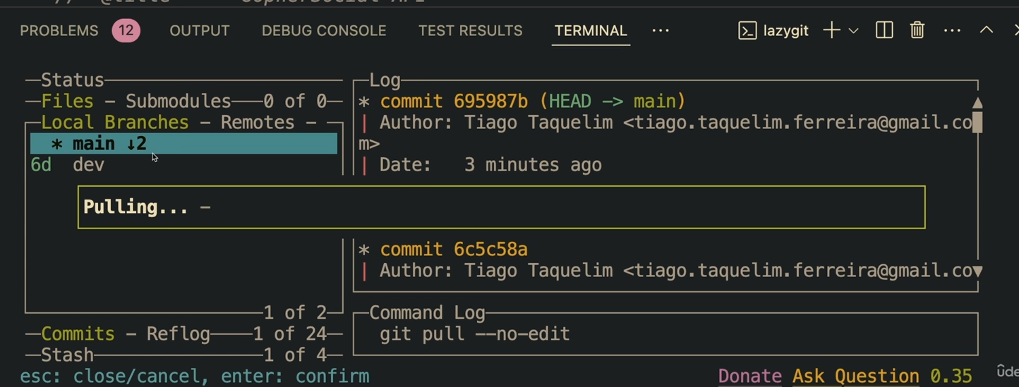

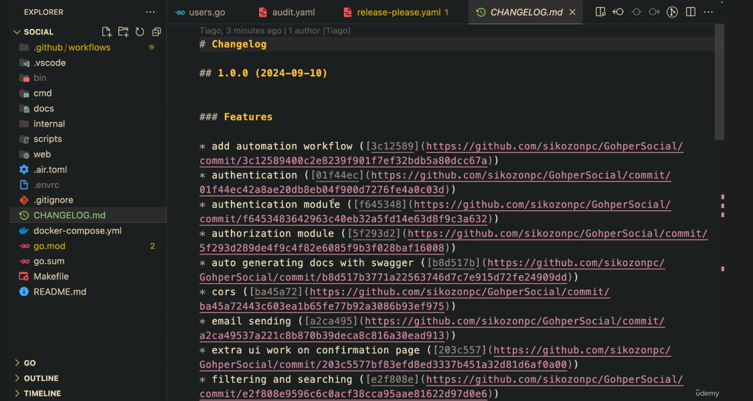

But first let's come here to our repository, because there's one thing that we still need to do here. I'm on my GitHub UI. If you're wondering this is called lazy git. It's a CLI tool that I use. So here you can see that I am two versions away from the origin. So I'm going to basically pull changes. So you can also just write git pull. And as you can see we got the changes that we have just merged there. So the changelog that that tool has just made, this is the changes. We are synced, uh, synced with all of the changes.

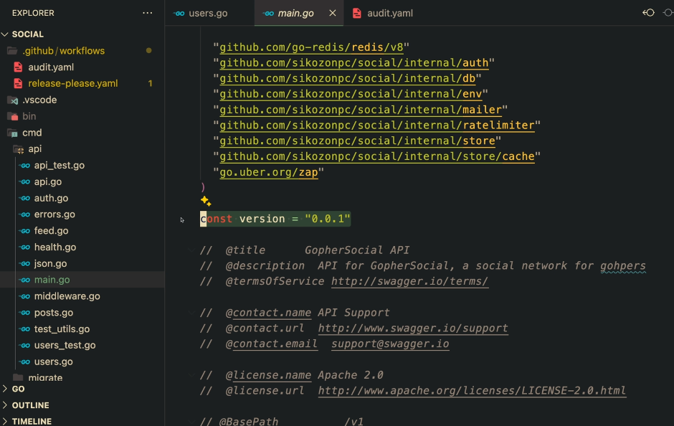

And finally, what it would be nice is that we also need to append or I mean, fix our version here because it still says 0.0.1. And this is also tied to our documentation, to our swagger docs. So this is out of sync. And we don't want to come here manually and change it.

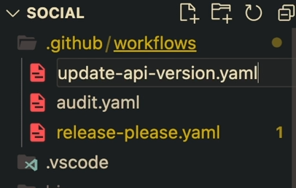

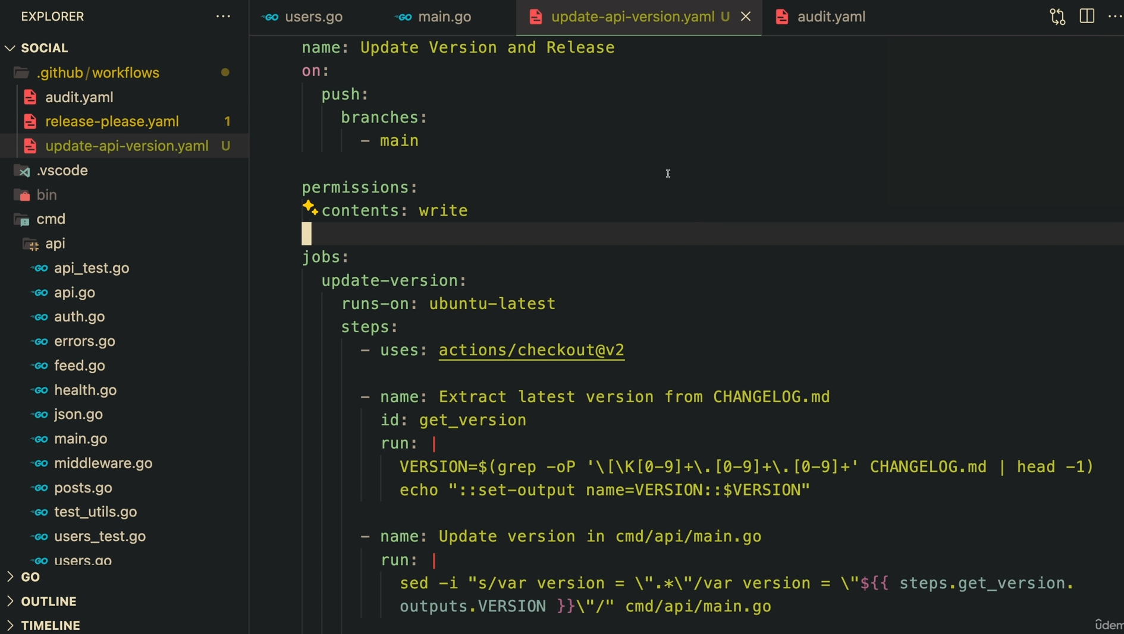

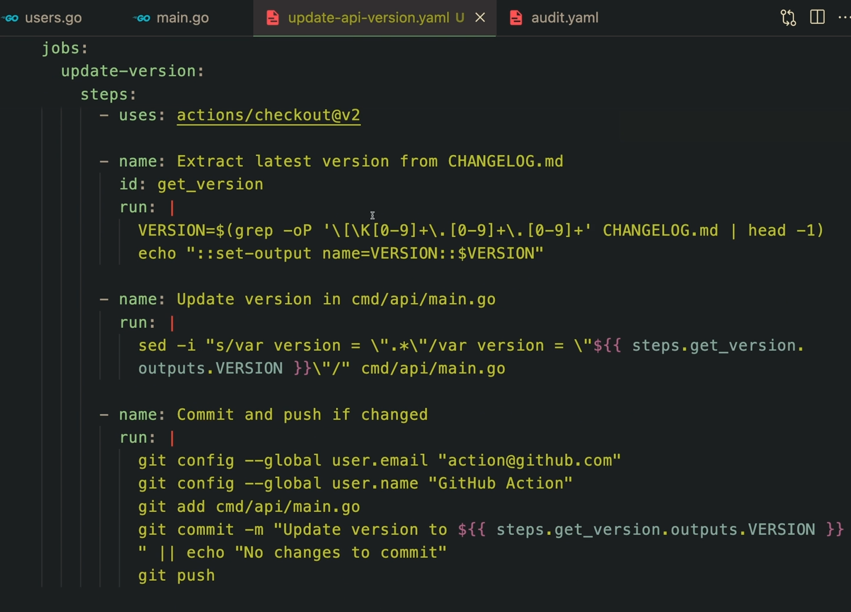

So what we're going to do is that we're going to write a script here, a workflow again, which is just going to do that for us. So updates uh, API version dot YAML. And this is the whole script. So it's very big. So I would recommend you to copy and paste it.

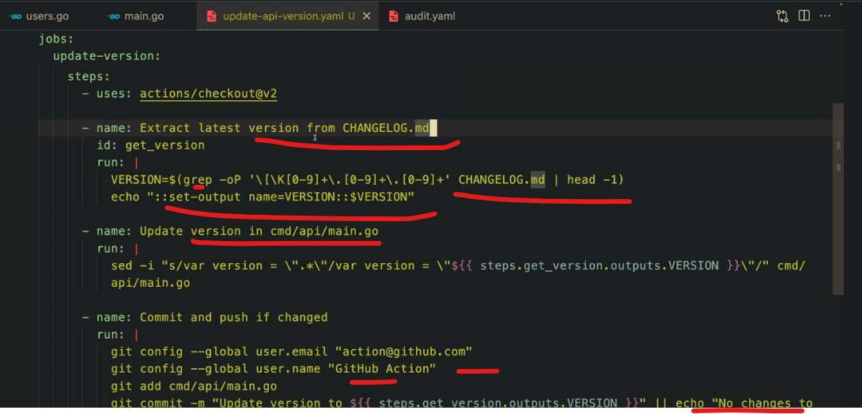

It's not complex though because it's just extracting the latest version from changelog. So this is doing some grep work on that file. And then it's updating our main.go. So if you have a different location don't forget to change it here. And then it's going to commit and push. If it has changed it's going to make a new commit there. And this is pretty much what it does. There's a lot of steps here because it's very verbose, but other than that it's pretty simple. So let's go ahead and actually make this a feature.

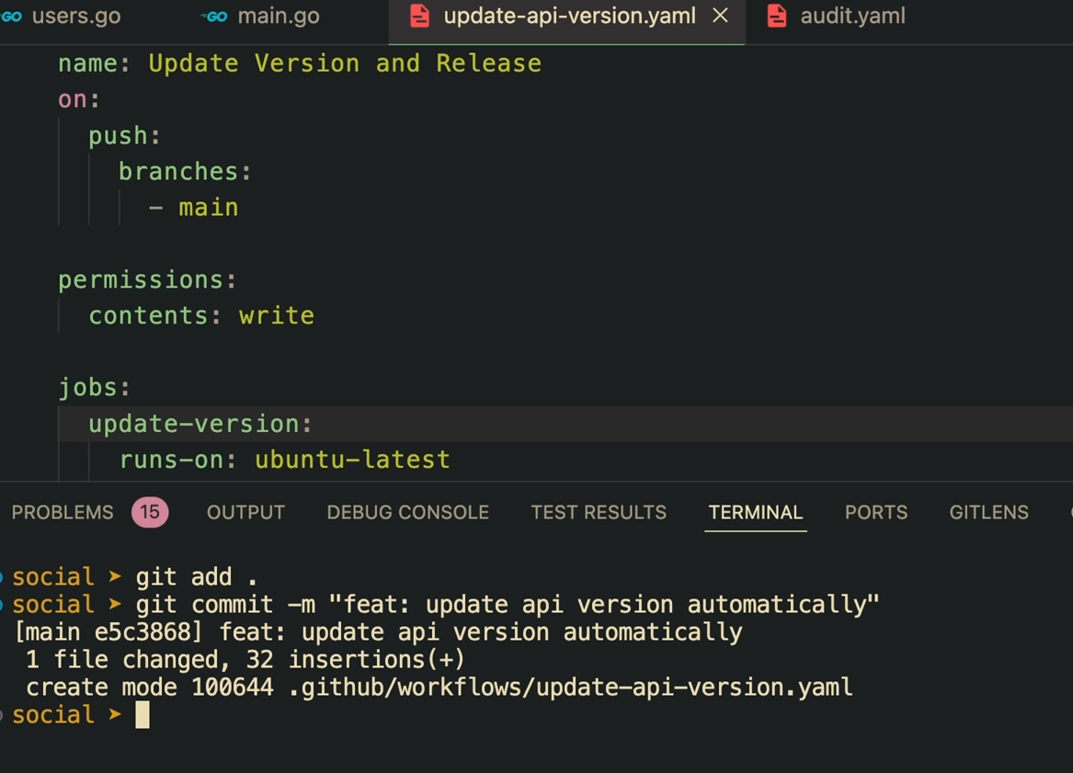

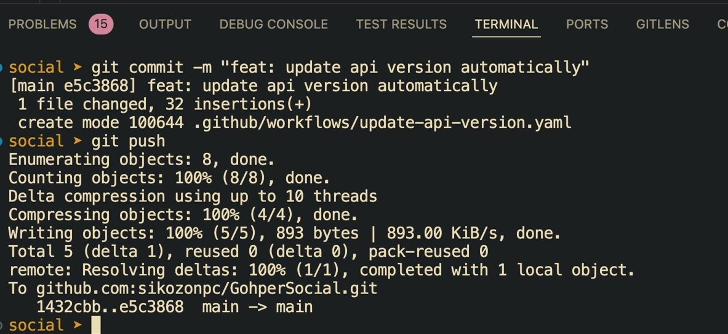

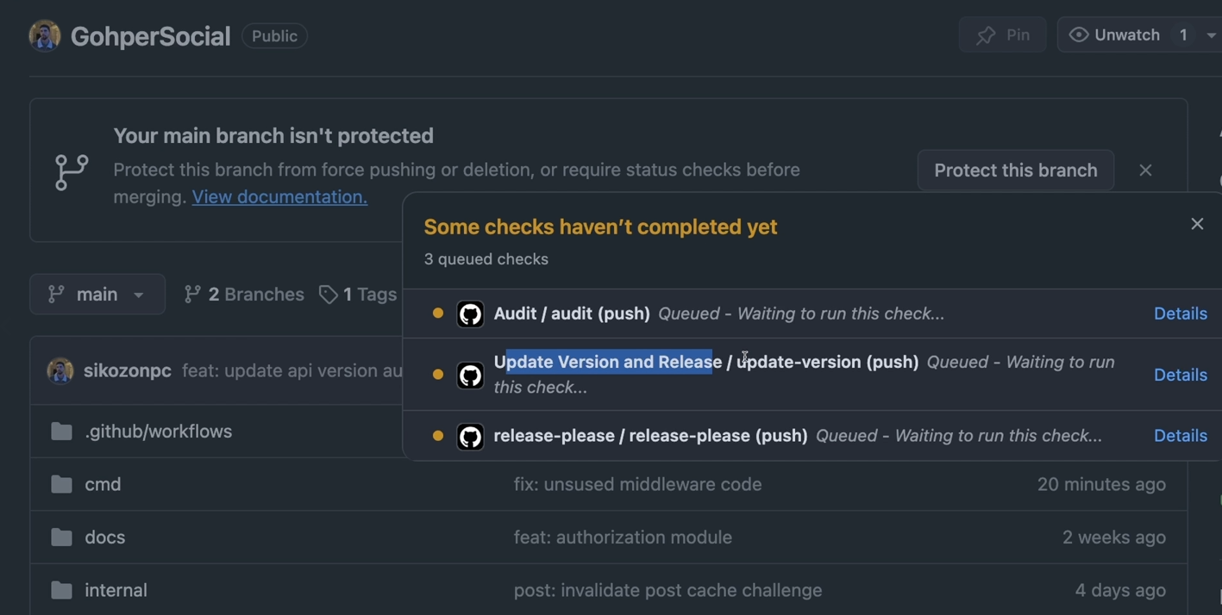

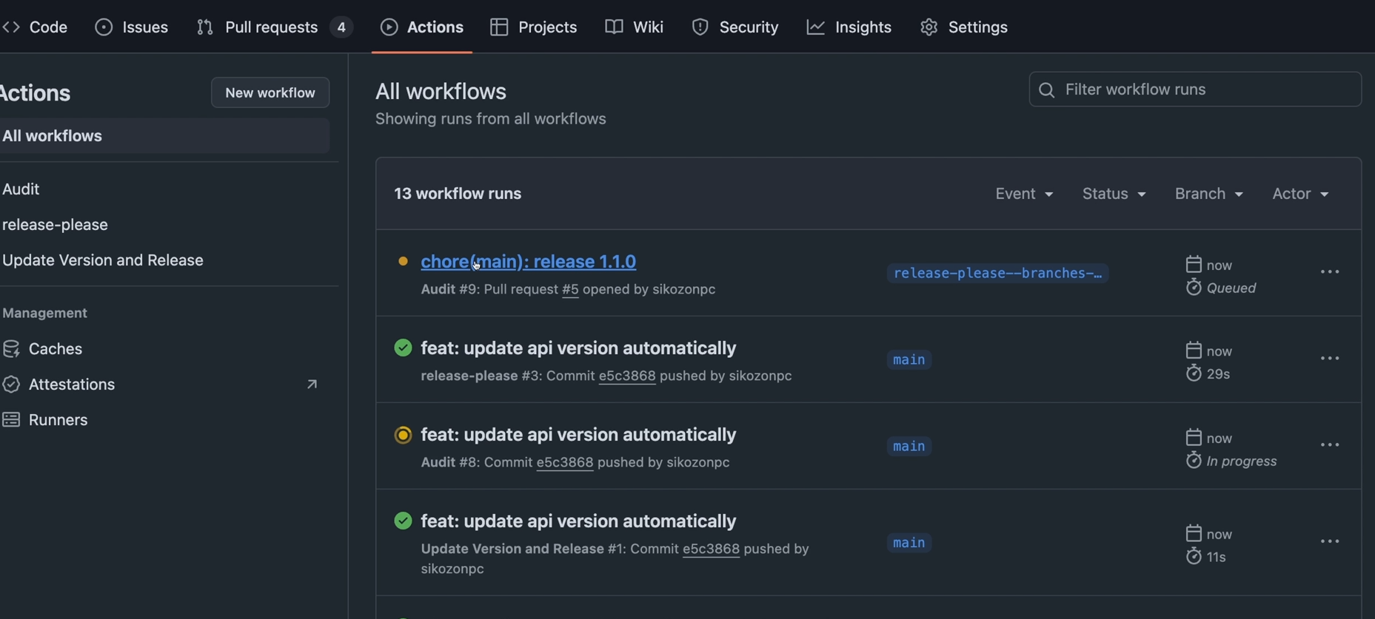

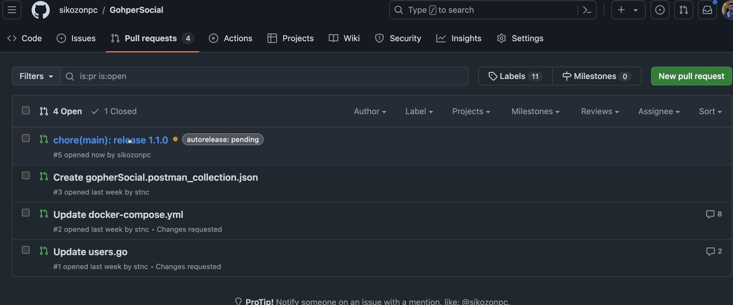

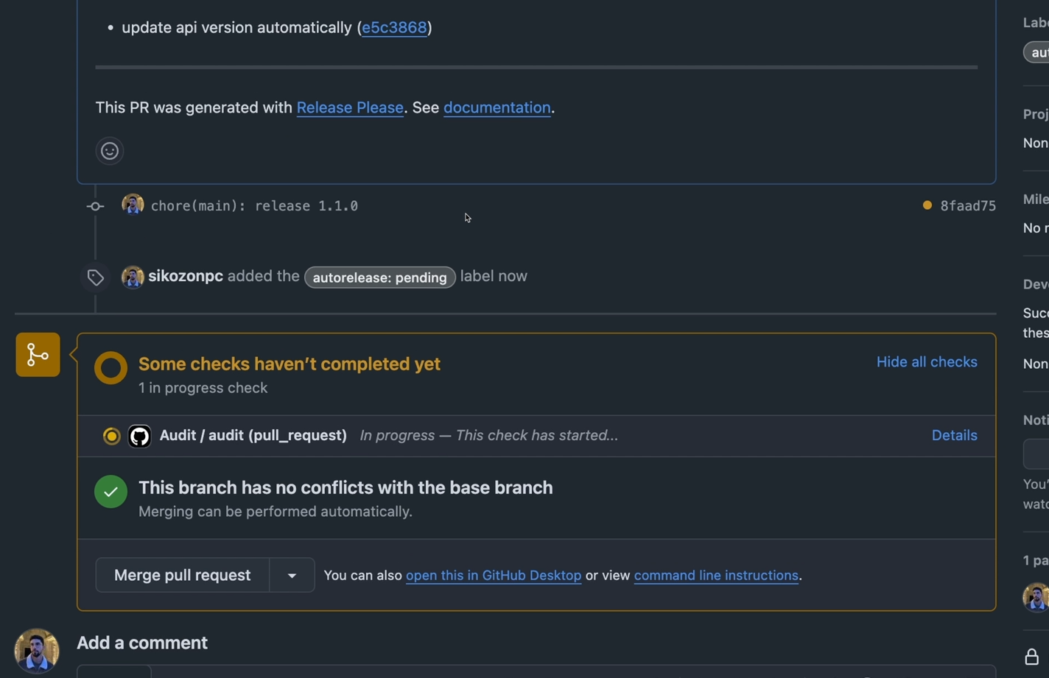

So let's git commit. And don't forget to put the fits. There we go. Let's do a git push. And now the whole flow is going to hopefully run again but with a new script. It's the last one for now I promise. So as you can see we have the update and release version. Now let's go here to the actions. And it's still not here. We need to wait a little bit. Or actually I have just refreshed as I was saying that. And you can see that it's actually, uh, it's not this one. You can see that we have here the pull request for that or the version 1.0. So let's come here. Let's just wait for this to build because this is also running the audits. We can actually disable this for this branch. Maybe. But still, I'm going to keep it because I don't know what this tool might add in our code base.

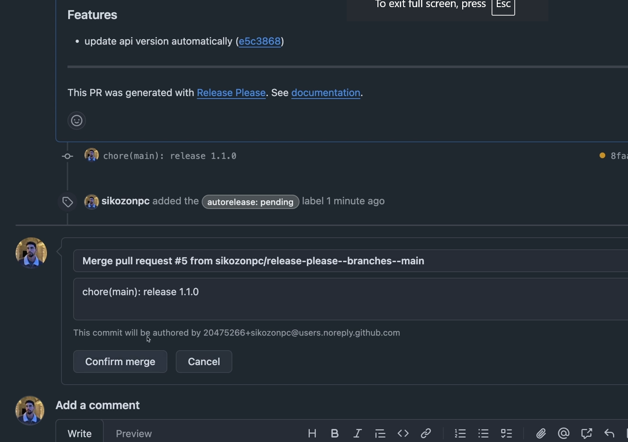

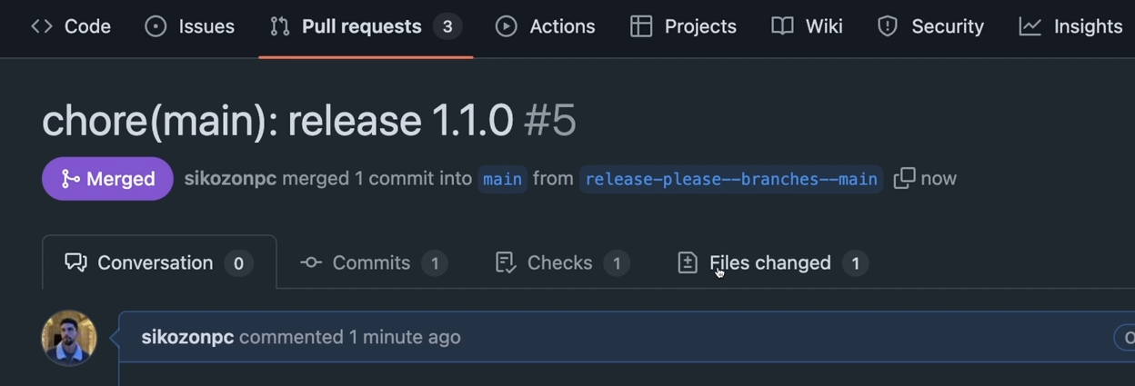

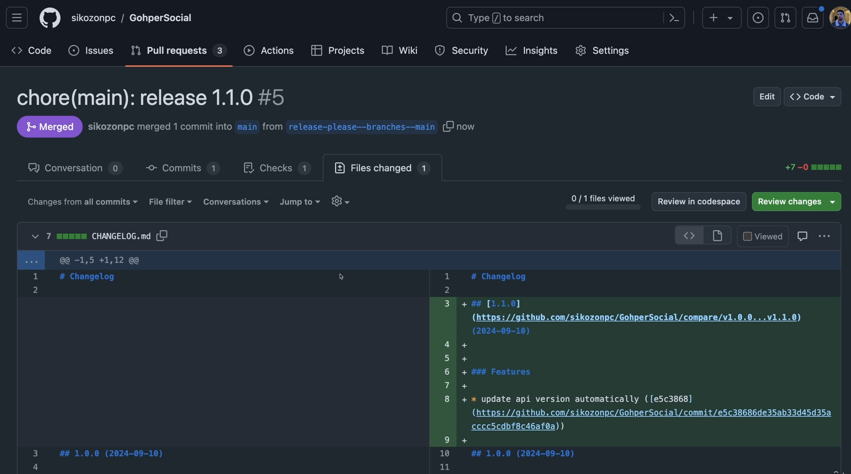

Let's just keep it. But what we can also do is just come here and merge pull request. I'm sure this is not going to add anything breaking because you can see here the changes as well. So just merge this. Let's go back to the actions.

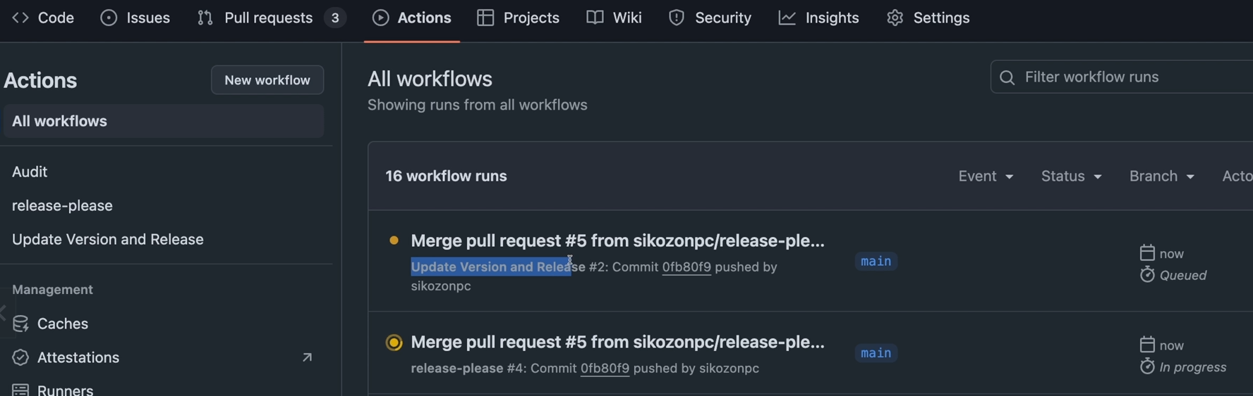

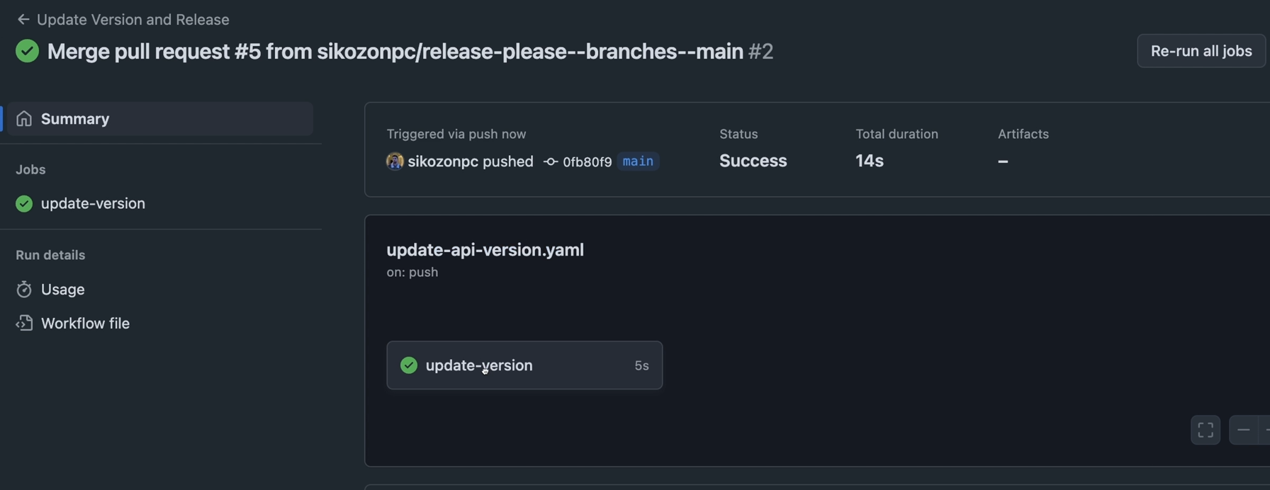

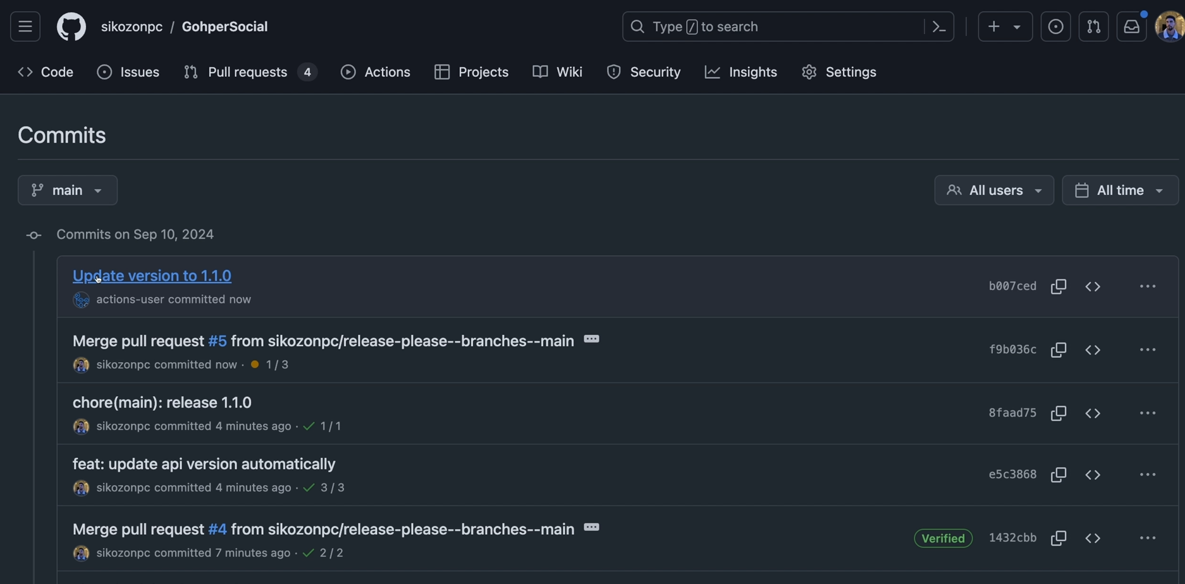

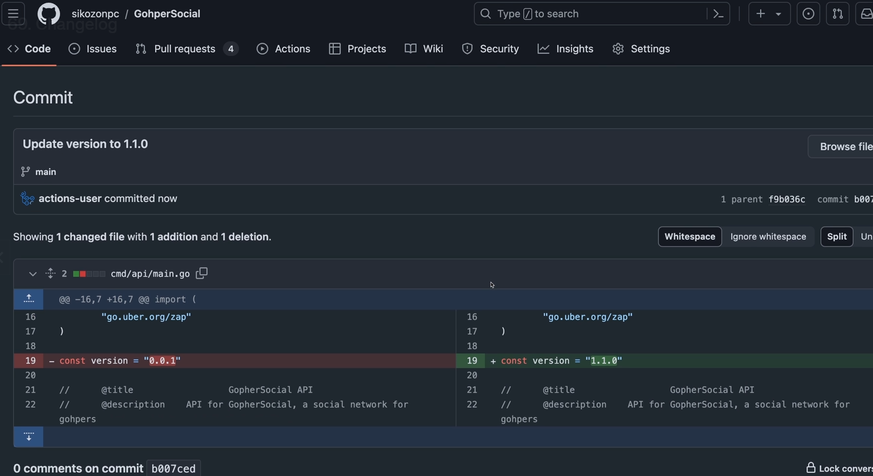

Let's go back to the actions. And you can see that now this has been deployed. So the update version and release. Let's click it. There we go. It was super fast. And what actually it did is if you go here to the code. So if you come here to the commit history and you can see this update version 21.1, if you click here on the commit details you can see what it did. It changed our version in our uh go project to 1.1.

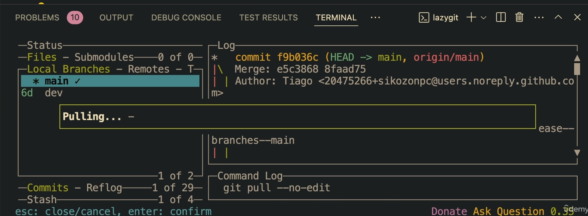

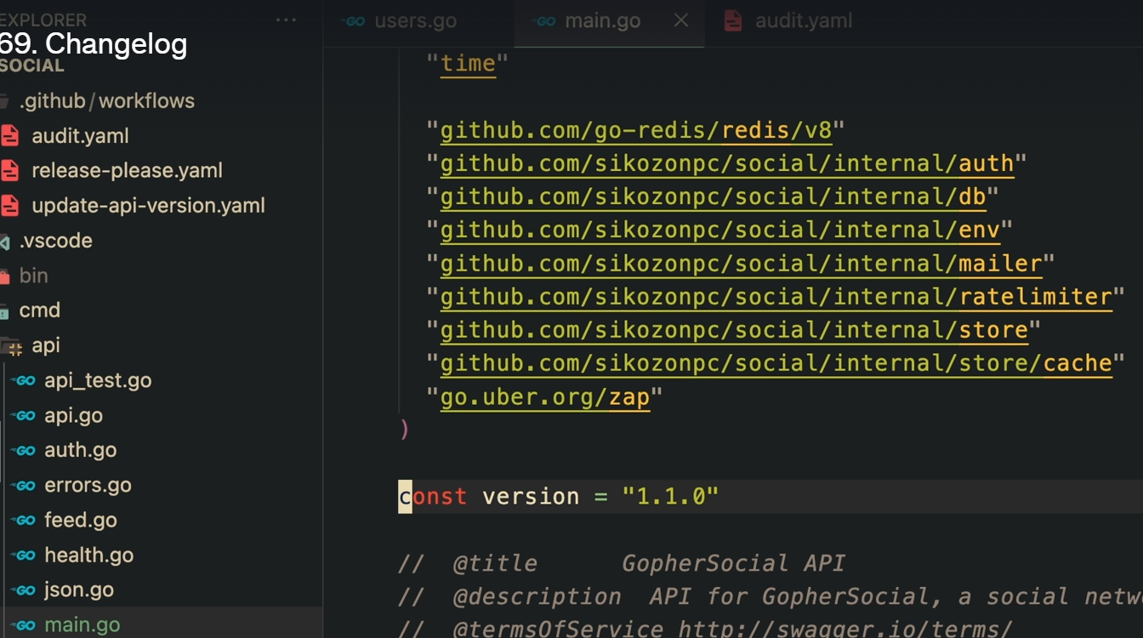

And let's go back to our project and let's actually fetch all these changes. Let's pull. And as you can see here is our version automatically increased. And this is pretty much it. So this is the whole flow for the CI CD.